
gf
Touchstones Project REACH
(Religious Education Arts Clearing House)

Lifespan RE Resources for Remembrance

Introduction
The content of this packet is shaped by the theme of Remembrance. As it turns out, it is grounded in all of our existing seven principles, as well as the 8th principle.

Remembrance operates on multiple levels.
- Remembrance has to do with our sense of self, our identity as we accumulate and unconsciously revise our autobiographical memories, which are explicit memories. This revision happens in small ways every time we remember something, as the present interacts with the past. See children’s’ books about memory/remembering at 3.1 to 3.5.
- Our sense of self is also informed by implicit memories, which, while unconscious, still influence behavior. These include traumatic experiences that we cannot recall consciously.
- Remembrance involves stories about us told to us by others. These are false memories because they are not based on our direct experience, but they are true memories to the extent that the story is true, and they, too, shape our identity.
- Remembrance involves family stories. Some of which include us, but most of which do not. Some are stories about people that we never met. Our family story does not begin with us. We are born into the middle of an ongoing story. It is a story that will continue beyond us when all of us that remains is a memory. See 3.13 to 3.17 for children’s books about story.
- Remembrance is affected by how we are socialized, both within our family and within society, especially what we are taught in school. This, too, influences our identity. Most people who are white in the West are racially socialized into a white privilege, if not white supremacy. Further, lighter skin tones are valued in many countries including India and China, thus conferring privilege. This involves colorism, which is prejudice or discrimination against individuals with a darker skin tone involving people of the same ethnic or racial group. See children’s books at 3.18-3.19, 3.21-3.22 & 3.35-3.47.
- Remembrance and identity are further shaped by the content and values of the history we are taught in school, as well as the holidays that we observe. Relative to history we have, as one example, the 1619 Project being opposed by the 45th US President’s 1776 Commission and their 1776 Report. The current crusade in the US against critical race theory and its relationship to replacement theory, while intellectually dishonest, shapes attitudes. See children’s books at 3.18 & 3.19. Consider this assertion: “Speaking the truth in times of universal deceit is a revolutionary act.” Relative to truth, while attributed to George Orwell, the author is anonymous.
  - For a thoughtful debate about issues related to teaching history, see Debatewise at https://debatewise.org/2850-history-dangers-of-teaching-in-schools/.
How we observe holidays also involves remembrance and identity. See children’s books at 3:24 to 3:31.
  - Relative to Columbus Day, consider its background at https://www.uua.org/multiculturalism/racial-justice/dod/indigenous-day. See children’s book at 3.32. There are two alternatives to this:
    - Indigenous People’s Day: A Proclamation on Indigenous Peoples’ Day, 2021, see https://www.whitehouse.gov/briefing-room/presidential-actions/2021/10/08/a-proclamation-indigenous-peoples-day-2021/, and Columbus Day Or Indigenous Peoples’ Day? https://www.npr.org/2019/10/14/769083847/columbus-day-or-indigenous-peoples-day.
    - Día de la Raza/Day of the Race, observed in Mexico and other Spanish speaking countries, this calls to mind those conquered, not the conqueror. What is Dia de la Raza? by Laurent Escobar, see https://pura-aventura.com/travel-stories/what-is-dia-de-la-raza, and The Timeline History of Celebrating (and Not Celebrating) Columbus Day, see https://www.smithsonianmag.com/history/timeline-history-celebrating-and-not-celebrating-columbus-day-180960736/, and La Dia de la Raza Information and Resource Page, see https://www.philasd.org/teachingandlearning/wp-content/uploads/sites/148/2017/10/Dia-De-La-Raza-One-Pager_100617.pdf.
Reconsidering Thanksgiving is also an important activity.
  - See the video, The First Thanksgiving: What Really Happened by Uncivil History at https://www.youtube.com/watch?v=ociHVDWxDaY (6:09). Well researched and enlightening.
  - See https://www.uua.org/action/statements/thanksgiving-day-reconsidered or a sermon by UUA President, Susan Frederick-Gray at https://www.uua.org/files/2020-11/11.20.20%20Harvest%20the%20Power-Susan%20Frederick-Gray.pdf.
  - See also Deconstructing the Myths of “The First Thanksgiving” by Judy Dow (Abenaki) (See https://static1.squarespace.com/static/6266ccfa6cbac67b9059e906/t/6269876937caa619cd83fc69/1651083113613/Deconstructing-First-Thanksgiving-Judy-Dow.pdf.
  - How to Re-teach Thanksgiving: Native American Children’s Books to Inspire New Traditions by Bri Hopkins at https://littlefeminist.com/2021/10/10/how-to-reteach-thanksgiving-native-american-childrens-books/ See children’s books at 3.33 &3.34.
  - While deconstructing or decolonizing Thanksgiving is important, that can be challenging with children. Another strategy is to share books about Native peoples so that their story is told side by side with a more traditional observance of Thanksgiving. See children’s books at 3:35 to 3:39.
Equally thoughtful are materials involving the terrible reality and legacy of Residential Schools
Canadian Residential Schools See children’s books at 3:42 to 3:47
  - The Canadian Unitarian Council was involved in the Truth, Healing and Reconciliation Initiative in Canada between Indigenous and Non-Indigenous peoples. See https://cuc.ca/social-justice/truth-healing-reconciliation/.
  - The Mohawk Institute Residential School was the first Canadian Indian residential school in Brantford, Ontario, Canada that opened in 1831. There were 139 Residential Schools. The last one closed in 1997.
  - The Truth and Reconciliation Commission of Canada worked from 2007 to 2015 to address the legacy of the Residential Schools. See https://www.rcaanc-cirnac.gc.ca/eng/1450124405592/15291060605250.
  - In Canada, Orange Shirt Day (aka National Day for Truth and Reconciliation), observed on September 30 since 2013, became federal holiday in 2021. See Orange Shirt Day: Uncovering the Dark History of Residential Schools in Canada by Nati Garicia at https://www.culturalsurvival.org/news/orange-shirt-day-uncovering-dark-history-residential-schools-canada
United States Residential Schools See children’s books at 3.40 & 3:41.
  - Between 1819 and 1969, the United States operated or supported 408 boarding schools across 37 states. See https://www.bia.gov/sites/default/files/dup/inline-files/bsi_investigative_report_may_2022_508.pdf.
  - In June 2022, H. R. 5444 was introduced in the House to establish the Truth and Healing Commission on Indian Boarding School Policies in the United States. No action to date. See text at https://www.congress.gov/bill/117th-congress/house-bill/5444/text
- Remembrance and identity are also shaped by participation in a Unitarian Universalist congregation through religious education, faith formation, and participation in holiday celebrations, as well as rituals from naming ceremonies to memorial services. See Rev. Gary Kowalski on developing a memorial ceremony after the death of a pet at https://www.spiritualityandpractice.com/book-reviews/excerpts/view/22312
- Notably, there is also the experience of observing memory loss in a loved one. See children’s books at 3.6. & 3.7 as well as remembrance associated with grief over the death of a loved one See children’s books at 3.8 to 3.12

Autumn is a season of remembrance as outlined in the following table. Please note that some observances happen at other times (e.g., Qingming Festival, aka Tomb Sweeping Day or, literally, Pure Brightness in China on April 5, 2023.)

Country or Tradition | Observance | Date | Children’s Books, Section 3.0
China | The Ghost Festival, (aka Zhongyuan Festival in Taoism and Yulanpen Festival in Buddhism) | August 12, 2022
Nepal | Gai Jatra (aka The Festival of the Cows), | August 12, 2022
Japan | Obon (aka Bon) | August 13-15, 2022 | 3.20
Korea | Chuseok | September 9-12, 2022
Hinduism | Pitru Paksha | September 10-25, 2022
Cambodia | Pchum Ben Festival | September 24-26, 2022
Canada | Orange Shirt Day (aka National Day for Truth and Reconciliation) | September 30, 2022 | 3.42
Judaism | Yizkor Memorial Service / Yom Kippur (held 4 times a year) | October 4-5, 2022
Canada | Thanksgiving | October 10, 2022
America | Columbus Day | October 10, 2022
Mexico, etc. | Día de la Raza/Day of the Race | October 17, 2022
Christian | All Saints | November 1, 2022
Mexico | Día de los Muertos Day of the Dead to remember children** | November 1, 2022 | 3.21 & 3.22
Christian | All Souls | November 2, 2022
Mexico | Día de los Muertos Day of the Dead to remember** adults | November 2, 2022 | 3.21 & 3.22
United States | Thanksgiving | November 24, 2022 | 3.33 & 3.34
Nigeria | Yoruban Odun Egungun | Nov 2022-Apr 2023

**Bringing the Dead to Life by Rev. Peter Morales is a good resource: see http://archive.uuworld.org/2000/0700feat3.html

Section 9.0 below has more information about remembrance of ancestors.

An easy and enjoyable way to explore remembrance with children and youth is to invite them to tell stories about their past. Have one person share and then the next, however, to assist with attention to listening, the next person to share a story must first briefly summarize the story that was just told.

Another important aspect of remembrance has to do with the history and meaning of some of the national holidays that are observed. As above, some reimagining may be required to better honor what really happened in the past.

Beyond exploring the nature of memory, there is also the possibility of exploring memory loss by elders, as well as grief over the death of a loved one.

Resources for Children
1.0: Pins
2.0: Wisdom Stories
The Tapestry of Faith stories are not listed, since those are easily accessible.
Children
2.1: The Gift of a Raspberry by Martha Dallas (448 words)
2.2: A Thanksgrieving Reflection by Rev. Isabel Call (709 words)
2.3: A Brother’s Sacrifice (557 words)
2.4: Kisa Gotami and the Mustard Seed (604 words)
2.5: Jim Thorpe (494 words)
2.6: Amrita’s Tree (1,137 words)
3.0: Children’s Books
Memory
3.1: When Things Are Hard, Remember by Joanna Rowland (Author) and Marcela Calderón (2021)
3.2: Once Upon a Memory by Nina Laden (Author), Renata Liwska (Illustrator) 2013
3.3: Memory Jar by Vera Brosgol (2021)
3.4: The Map of Good Memories by Fran Nuño (Author), Zuzanna Celej (Illustrator), and Jon Brokenbrow (Translator) 2017
3.5: The Memory Coat by Elvira Woodruff (Author) and Michael Dooling (Illustrator) (1999)
Memory Loss
3.6: The Remember Balloons by Jessie Oliveros (Author) and Dana Wulfekotte (Illustrator) (2018)
3.7: Wilfrid Gordon Macdonald Partridge by Mem Fox (Author) and Julie Vivas (Author) (1987)
Grief

3.8: The Memory Box: A Book About Grief by Joanna Rowland, author and Thea Baker, illustrator (2017)
3.9: Grandpa’s Stories by Joseph Coelho (Author) and Allison Colpoys (Illustrator) (2019)
3.10: Map of Memory Lane by Francesca Lynn Arnoldy (Author) and Young Ju Kim (Illustrator) (2021)
3.11: The Memory Tree by Britta Teckentrup (2014)
3.12: The Memory String by Eve Bunting (Author) and Ted Rand (Illustrator) (2015)
Story
3.13: I Am a Story by Dan Yaccarino (2016)
3.14: The Storyteller by Evan Turk (2016)
3.15: Once Upon a Winter Day by Liza Woodruff (2020)
3.16: Telling Stories Wrong by Gianni Rodari (Author) and Beatrice Alemagna (Illustrator) (2022)
3.17: Once Upon a Baby Brother by Sarah Sullivan (2010)
Black Experience
3.18: Circle Unbroken by Margot Theis Raven (Author) and E. B. Lewis (Illustrator) (2007)
3.19: The 1619 Project: Born on the Water by Nikole Hannah-Jones and Renée Watson (Authors) and Nikkolas Smith (Illustrator) 2021
Obon
3.20: Suki’s Kimono by Chieri Uegaki (Author) and Stéphane Jorisch (Illustrator) (2005)
…… Dia de los Muertos
3.21: The Remembering Day / El dia de los muertos by Pat Mora (Author) and Robert Casilla (Illustrator) (2015)
3.22: Maria Molina and the Days of the Dead by Kathleen Krull (Author) and Enrique Sanchez (Illustrator) (1994)
Samhain
3.23: Rupert’s Tales: The Wheel of the Year - Samhain, Yule, Imbolc, and Ostara by Kyrja (Author) and (Illustrator) (2012)
Memorial Day / Remembrance Day / Veteran’s Day / Vietnam Memorial
3.24: A Day for Rememberin’: Inspired by the True Events of the First Memorial Day by Leah Henderson (Author) and Floyd Cooper (Illustrator) (2021)
3.25: Let’s Celebrate Memorial Day by Barbara deRubertis (Author) (2016)
3.26: Memorial Day Surprise by Theresa Martin Golding (Author) and Alexandra Artigas (Illustrator) (2004)
3.27: A Poppy Is to Remember by Heather Patterson (Author) and Ron Lightburn (Illustrator) (2004)
3.28: The Poppy Lady: Moina Belle Michael and Her Tribute to Veterans by Barbara E. Walsh (Author) and Layne Johnson (Illustrator) (2012)
3.29: America’s White Table by Margot Theis Raven (Author) and Mike Benny (Illustrator) (2005)
3.30: The Wall by Eve Bunting (Author) and Ronald Himler (Illustrator) (1992)
9/11
3.31: Branches of Hope: The 9/11 Survivor Tree by Ann Magee (Author) and Nicole Wong (Illustrator) (2021)
Columbus Day
3.32: Christopher the Ogre Cologre, It’s Over! (The Real History of Christopher Columbus) by Dr. Oriel Maria Siu (Author) and Víctor Zúñiga (Illustrator) (2021)
Thanksgiving
3.33: Keepunumuk: Weeâchumun’s Thanksgiving by Danielle Greendee, Anthony Perry & Alexis Bunten (Authors) and Gary Meeches Sr (Illustrator) (August 2022)
3.34: Our Table by Peter H. Reynolds (Author, Illustrator) 2021
Indigenous Peoples’ Stories
3.35: We Are Grateful: Otsaliheliga by Traci Sorell (Author) and Frane Lessac (Illustrator) (2018)
3.36: We Are Still Here!: Native American Truths Everyone Should Know by Traci Sorell (Author) and Frane Lessac (Illustrator) (2021)
3.37: We Are Water Protectors by Carole Lindstrom (Author) and Michaela Goade (Illustrator) (2020)
3.38: The People Shall Continue by Simon J Ortiz (Author) and Sharol Graves (Illustrator) (2017)
3.39: Fry Bread: A Native American Family Story by Kevin Noble Maillard (Author) and Juana Martinez-Neal (Illustrator) (2019)
Residential Schools in the US & Canada
3.40: Remembering Green, An Ojibwe Girl s Tale by Lisa Gammon Olson (Author) and Lauren Rutledge (Illustrator) (2020)
3.41: Jim Thorpe’s Bright Path by Joseph Bruchac (Author) and Nelson;S. D. (Illustrator) 2004
3.42: The Orange Shirt Story by Phyllis Webstad (Author) and Brock Nicol (Illustrator) (2018)
3.43: Stolen Words by Melanie Florence (Author) and Gabrielle Grimard (Illustrator) (2017)
3.44: When I Was Eight by Christy Jordan-Fenton & Margaret Pokiak-Fenton (Authors) and Gabrielle Grimard (Illustrator) (2013)
3.45: I Am Not a Number by Jenny Kay Dupuis & Kathy Kacer (Authors) and Gillian Newland (Illustrator) (2016)

3.46: Shi-shi-etko by Nicola I. Campbell, author and Kim LaFave, illustrator (2005)

3.47: Shin-chi’s Canoe by Nicola I. Campbell, author and Kim LaFave, illustrator (2005)
Other
3.48: Please Try to Remember the First of Octember! by Dr. Seuss writing as Theodore Lesieg

4.0: Curriculum & Theme-Based Classroom Activities for Children

from Tapestry of Faith
4.1: Chalice Children: A Program about Our Unitarian Universalist Community for Preschoolers
4.1.1: Session 4: Making Chalices
4.1.2: Session 6: Chalice Necklaces
4.1.3: Session 8: Fruit Chalices
4.2: Creating Home: A Program on Developing a Sense of Home Grounded in Faith for Grades K-1
4.2.1: Session 2: Symbols of Faith
4.2.2: Session 9: Our Ancestral Home
4.2.3: Session 16: Memories of Home
4.3: Wonderful Welcome: A Program for Children Grades K-1
4.3.1: Session 6: The Gift Of Friends
4.3.2: Session 8: The Gift Of Families
4.4: Love Surrounds Us: A Program on the UU Principles and Beloved Community for Grades K-1
4.4.1: Session 7: Love Surrounds Us in Ritual
4.4.2: Session 8: Love Surrounds Us in Our History
4.4.3: Session 15: Caring for the Earth
4.5: World of Wonder: A Program on the Seven Principles of Unitarian Universalism for Grades K-1
4.5.1: Session 3: Thanks Be for Trees!
4.6: Moral Tales: A Program on Making Choices for Grades 2-3
4.6.1: Session 8: Do unto Others
4.7: Faithful Journeys: A Program about Pilgrimages of Faith in Action for Grades 2-3 (see 14 sessions)
4.8: Love Will Guide Us: A Program for Grades 2-3 that Applies the Wisdom of the Six Sources to the Big Questions
4.8.1: Session 6: Love Is Eternal
4.8.2: Session 11: Love and Gratitude
4.9: Signs of Our Faith: A Program about Being UU Every Day for Grades 2-3
4.9.1: Session 5: We Revere Life
4.9.2: Session 8: Memorial Rituals
4.10: Toolbox of Faith: A Program That Helps Children Discover the Uses of Faith, Grades 4-5 (see 7 sessions)
4.11: Windows and Mirrors: A Program about Diversity for Grades 4-5 (see 6 sessions)
4.12: Love Connects Us: A Program on Living in Unitarian Universalist Covenant for Grades 4-5 (see 7 sessions)
4.13: Sing to the Power: A Social Justice Program for Children Grades 4-5 (see 9 sessions)
4.13.1: Session 2: The Power of Roots
4.14: Riddle and Mystery: A Program on the Big Questions for Grade 6
4.14.1: Session 3: Looking Toward Tomorrow
4.14.2: Session 6: Thinking of Death
4.15: Amazing Grace: A Program about Exploring Right and Wrong for Grade 6
4.15.1: Session 6: The First U
4.15.2: Session 7: The Second U
4.16: Heeding the Call: A Program on Justice-making for Junior High School Youth (see 5 sessions)
4.17: Building Bridges: A World Religions Program for 8th-9th Grades (see 2 sessions)
4.18: Miracles, Wide Age Span (see 3 sessions)
4.19: Gather the Spirit: A Multigenerational Program about Stewardship (see 2 sessions)
Resources for Youth
5.0: Curriculum & Theme-Based Classroom Activities for Youth
Tapestry of Faith
Youth
5.1: A Chorus of Faiths: A Program That Builds Interfaith Youth Leaders (see 6 sessions)
5.3: A Place of Wholeness: A Program for Youth Exploring Their Own Unitarian Universalist Faith Journeys (see 10 sessions)
5.4: Virtue Ethics: An Ethical Development Program for High School Youth
5.4.1: Workshop 5: Fairness
6.0: Readings
6.1: Bringing the Dead to Life by Rev. Peter Morales
6.2: Remember by Joy Harjo (209 words)
6.3: One Tree’s Growth of Leaves by Phillip Lewis (182 words)
6.4: The Spiritual Practice of Remembering by Margaret Bendroth (239 words)
6.5: Remembrance, Reverence, and Resurrection by Cornel West (200 words)
6.6: Remember to Remember by Joseph Bruchac (241 words)
6.7: Remember the Sabbath by Wayne Muller (275 words)
6.8: These Hands Remember by Barry Lopez (132 words)
6.9: Today, I Will Remember by Joseph Cardillo (188 words)
6.10: Singing the Child’ Song by Alan Cohen (254 words)
6.11: Remember the Miracle of Existence by Rosie Bell (286 words)
6.12: Make Mourning into Memory by Ari Berk (275 words)
6.13: Singing Your Song by Alan Cohen (177 words)
6.14: Remember Criticism as Sacred Speech by Donna Schaper (258 words)
6.15: Remembering the Three Sisters by Robin Wall Kimmerer (331 words)
6.16: Remember Your Nature by Shannon Lee (176 words)
7.0: Popular Music
7.1: Good Old Day by Macklemore, featuring Kesha (4:08)
7.2: Father and Daughter by Paul Simon (4:07)
7.3: Gabriel and Me by Joan Baez (3:43)
7.4: Memories by Maroon 5 (6:50)

7.5: Hello in There by (1) John Prine (5:58) & (2) Bette Midler (4:17)
7.6: I Will Remember You by Sarah Mclachlan (3:39)
7.7: Every breath you take / I’ll be missing you (Sting / P. Diddy) by Oberstufenchor Cusanus Gymnasium (6:24)
7.8: Hold Onto the Memories by Corey Tynan (3:31)
7.9: Photograph by Ed Sheeran (4:34)
7.10: The Circle Game by Joni Mitchell A & Buffy Saint Marie B
7.11: Breaths by Sweet Honey in the Rock (4:08)
7.12: Memory by Barbra Streisand (3:57)
7.13: The Way We Were by Barbra Streisand (3:31)
7.14: 7 Years by Lukas Graham (3:59)
7.15: Monsters by James Blunt (4:35)
7.16: Since I Lost You by Genesis / Phil Collins (4:07)
7.17: Tears in Heaven by Eric Clapton (4:34)
7.18: My Hometown by Bruce Springsteen (4:37)
7.19: See You Again by Carrie Underwood (4:09)
7.20: Try to Remember by Brothers Four (3:01)
7.21: Kids by One Republic (4:28)
7.22: Memories by Shawn Mendes (3:52)
7.23: Sixteen by Thomas Rhett (3:03)
7:24: Saturn by Sleeping at Last (4:49)
7:25: Remembering by Ashley Campbell (3:46)
8.0: Videos

8.1: Remembrance by Cas Nykopp (2:35)

8.2: 911 Remembrance by Delphinidea (3:58)

8.3: Remember the Ancestors (1:20)

8.4: Remembrance by SKO Films (2:32)

8.5: Remembrance by Carlos Dalmau (:15)

8.6: Rethink Remembrance by Cole Paviour (0:32)

8.7: What is Day of the Dead? by National Geographic (2:06)

8.8: Dia De Los Muertos by Team Whoo Kazoo (3:07)

8.9: Dia de Los Muertos: A Brief Overview by National Hispanic Cultural Center (5:07)

8.10: Namwayut: we are all one. Truth and reconciliation in Canada by CBC (4:20)

8.11: How “The 1619 Project” underscores connection between slavery and modern America by PBS News Hour (6:53)

8.12: The Atlantic slave trade: What too few textbooks told you by Anthony Hazard (5:38)
8.13: History vs. Christopher Columbus by Alex Gendler (5:54)
8.14: Changing Columbus Day to Indigenous Peoples’ Day Gains National Approval by Voice of America (3:05)
8.15: Happy Indigenous Peoples’ Day! by Deb Haaland, Secretary of the Interior (1:02)
8.16: Historian Roxanne Dunbar-Ortiz: Indigenous Peoples’ Day Shared with Columbus Day “Contradiction” by Democracy Now (17:31)
8.17: Mexico marks ‘race day’ in recognition of mixed heritage by Al Jazeera English (2:49)

Ted Talks

8.18: How memories form and how we lose them by Catharine Young (4:19)
8.19: The benefits of daydreaming by Elizabeth Cox (4:02)
8.20: Does stress affect your memory? by Elizabeth Cox (4:43)
8.21: Why elephants never forget by Alex Gendler (5:22)
8.22: How daydreams become life’s adventures by Jim Prescott (13:07)
8.23: Mindwandering by Malia Mason (8:58)
9.0: Appendix: Twelve Observances Related to Ancestor Remembrance and Worship

List of Resources
Resources for Children

1.0: Pins

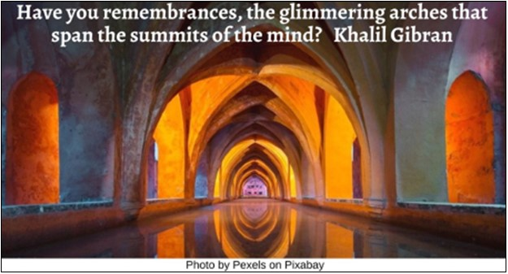



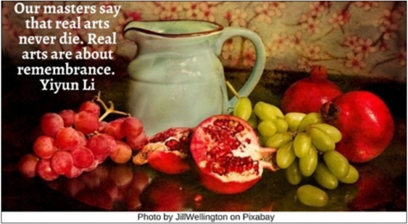

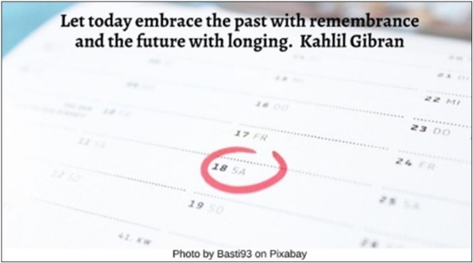

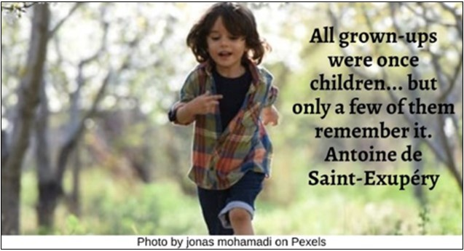

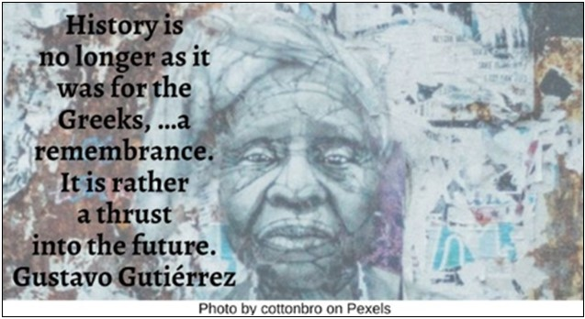

Resources for Children
2.0: Wisdom Stories
The Tapestry of Faith stories are not listed, since those are easily accessible in the curricula listed.
Children
2.1: The Gift of a Raspberry by Martha Dallas (448 words)
This was created as a Message for All Ages for a service honoring Yom Ha’Shoah, the Jewish holiday for Holocaust Remembrance. …
Once there was a place that was very bleak and dreary. All the colors there were only shades of gray and brown. Nothing grew there: no grass, no flowers, no trees. And this place was surrounded by walls and fences.
People lived in this place. Every day they were forced to work digging holes, and then shoveling the dirt they’d dug out, back into those same holes. This work made them feel tired and their bodies ached. And they felt hopeless, for their work never amounted to anything.
The food they ate was just a little bread and some broth. Their bellies were never full, and they were always hungry. Plus, they got sick a lot, for this food wasn’t nutritious enough to keep them healthy.
At night, they slept, if they slept, on hard wooden beds. They had no pillows nor blankets, so they were cold and they shivered much of the night. When they did sleep, they had bad dreams, and when they woke up, they were just as tired as they’d been the night before.
One morning in this place, a girl went out. And suddenly, she saw something on the ground. Something special and precious. It was...a red raspberry!! Quickly, she picked it up and slipped it into her pocket. She kept it safe there all day, and that night, she found a leaf that had blown in from the outside. She put the leaf in her hand and placed the red raspberry on the leaf, and went to her friend, and presented it to her friend as a gift. And her friend received it.
I tell you this story, not only because it reminds us that in the most sad, hopeless, bleak and dreary places, we can – if we keep our eyes open – find miraculous surprises – treasures that are bright and sweet and delicious, like that raspberry. But more importantly, when we find these treasures, we can give them up, give them away, give them to—a friend.
This story is true. It actually happened. And I want you to remember this story. So today I brought...some raspberries. And I invite you to come take one. Take it and hold it, and when everyone who wants one has one, I’ll tell you what to do next…
Now, holding your raspberry, imagine that your world is dreary, sad, hopeless, and bleak. And imagine that your friend has just given you this raspberry. This raspberry was the one thing your friend truly owned, and she chose to make it a gift for you. And when you’ve imagined that, I invite you to enjoy your raspberry, to eat your raspberry, and to always remember.
Prop: fresh raspberries
Credit goes to the New England Holocaust Memorial in Boston, MA, where I first encountered this quote: “Ilse, a childhood friend of mine, once found a raspberry in the camp and carried it in her pocket all day to present to me that night on a leaf. Imagine a world in which your entire possession is one raspberry and you give it to your friend.” —Gerta Weissman Klein
Deported from Germany as a teenager, she later married the U.S. Army soldier who led the troops that rescued her from Sobibor.
Source: https://www.uua.org/worship/words/story/gift-raspberry

2.2: A Thanksgrieving Reflection by Rev. Isabel Call (709 words)
I want to tell you about my bicycle. The frame is a sparkly kind of blue and it has pink handlebar tape. And guess what color the wheels are? Lime green!
I love my bicycle. Now suppose this was your bicycle. And suppose one day you biked to school and totally forgot to lock your bike when you got there. And then, when it was time to leave, you went outside to get on your bike and… No bike! It was stolen. Bah!
Okay, so you had to get a ride home and figure out how to get to school from now on. Then, in art class the next week, someone brings in a sculpture of a turkey they’ve made. It has a sparkly blue body made of pieces of metal, a big round tail with a lime green circle around it, pink feet curving underneath it, ... and a bicycle seat for a head. In fact, the whole thing is made from a bicycle. And you realize it’s your bicycle. Your former, stolen, cut-up-into-pieces bicycle.
But before you can say anything, your classmates are cheering and the principal decides to make the sculpture the new school mascot. And she institutes a new school holiday called Turkey Creativity Day, and every year from now on, everybody gets to spend a whole day making art.
Now, nothing against creativity but… this is kind of a nightmare.
I’m telling you this story because it’s basically the story of Thanksgiving — except Thanksgiving is worse. I’ve started writing and saying “Thanksgrieving” instead of Thanksgiving, because in popular culture, we’ve come to see Thanksgiving as a commemoration of a friendly feast shared by Native Americans and European settlers... but this is like Turkey Creativity Day: a really nice idea that covers up theft and treachery.
Although both Native American and Europeans had feasts expressing gratitude during harvest time, the Europeans who arrived on this continent were incredibly destructive to Native American communities. The Wampanoag man often celebrated as a friend of the pilgrims, Tisquantum, spoke English because traders had enslaved him and forcibly taken him to England. When he finally escaped and made his way back home, his community had all died from smallpox his captors had left behind. He was friendly to the pilgrims who moved into the land of his people because none of his own people were left. He was able to find work with the pilgrims as a translator and helped them negotiate treaties.
But as we know, treaties between European settlers and the indigenous residents of America have not been honored by the new arrivals. And although there’s some evidence of a shared meal between Europeans and Wampanoag people in 1621, the holiday may actually have started a few decades later, in May 1637, when English and Dutch mercenaries attacked the Pequot Tribe. They killed over 700 people, and the next day the governor of the Massachusetts Bay Colony declared a day of Thanksgiving in celebration.
Since then, various governors and presidents called for days of Thanksgiving to commemorate various events, but it didn’t get formalized into an annual holiday until Abraham Lincoln chose a Thursday in November in 1863 to celebrate Civil War victories.
Now, nothing against gratitude, but the legacy of Thanksgiving is a nightmare. The 400-year-old story we’ve heard about harmony between people of different backgrounds just isn’t true.
The United American Indians of New England have commemorated a National Day of Mourning every fourth Thursday in November since 1970. They write, “Thanksgiving day is a reminder of the genocide of millions of Native people, the theft of Native lands, and the relentless assault on Native culture. Participants in National Day of Mourning honor Native ancestors and the struggles of Native peoples to survive today. It is a day of remembrance and spiritual connection as well as a protest of the racism and oppression which Native Americans continue to experience.”
It may be uncomfortable to hear this as you prepare for your Thanksgiving festivities. We celebrate Thanksgiving because gratitude is essential to human life. But grief is essential for healing our history of violence. It’s really hard to be thankful and sorrowful at the same time. But this is life: sometimes, joy and sorrow come together.
Source: https://www.uua.org/worship/words/story/thanksgrieving-reflection

2.3: A Brother’s Sacrifice (557 words)
This is a fictional account of the creation of Dürer’s work, “Praying Hands.” It was inspired by another story about the praying hands, but attempts to be truer to what is known about Albrecht and Hans Dürer.
Hundreds of years ago in the fifteenth century a family lived in a tiny village near Nuremberg in Germany. The village was tiny, but not the family. Albrecht Dürer the Elder and his wife Barbara had eighteen children. He was a goldsmith. On many days he worked sixteen hours or more to earn enough money to take care of his family. Still, they were quite poor.
Despite what appeared to be a hopeless situation, two of the sons shared a dream. They both wanted to study art, but they knew that their father could not afford to have them both serve as an apprentice to a famous artist in Nuremberg at the same time.
They talked about their dreams night after night. Then they made a pact. They would toss a coin. The one who lost would work in the nearby coal mines and help support the family while the brother who won studied art. Then, when that brother completed his studies, he would support the family through the sale of his artwork so that the second brother could become an apprentice and study art.
They tossed a coin on a Sunday morning after church. Albrecht Dürer won the toss and moved to Nuremberg to serve as an apprentice to Michael Wolgemut who had a large workshop that produced a variety of works of art, including woodcuts for books. The year was 1486 and Albrecht was just 15 years old. His brother, Hans, went to work in the coal mine.
After he completed his apprenticeship, Albrecht followed the German custom of taking a Wanderjahre or “wander year” to study with other famous artists. That year turned into four as Albrecht worked tirelessly to develop his skills and become a master artist. He returned home in 1494 to marry Agnes Frey following an arrangement made by his parents during his absence. At the reception after the wedding, Albrecht told Hans that it was now his turn to become an apprentice and study art.
Hans was moved by Albrecht’s offer, but wondered if he could become as skilled as his brother. Hans said, “I’m not sure that I should even try. My hands were damaged working in the mine. Look at them. Sometimes it is even hard to hold a brush.” “Nonsense,” said Albrecht. “You must do what you love. Learn to be an artist and pray that your hands will continue to heal so that you can create what you imagine.”
Hans became an apprentice to his brother. Daily, Albrecht instructed his younger brother, often looking at his hands as he worked. Hans developed the skills necessary to become a gifted artist. Later, like many other Nuremberg artists, Hans went to live and work in Kraków where he became the court painter for King Sigismund I of Poland. This connects him with our own religious tradition since King Sigismund was the great uncle of John II Sigismund Zápolya, King of Transylvania, and the only Unitarian king in history.
In 1508, Albrecht created a pen and ink sketch called “Praying Hands” (in German Betende Hände). It has become his most well-known work. Many people wonder if those were the hands of his brother, who had sacrificed so much so Albrecht could study what he loved. The two brothers are memories, but this famous sketch reminds us of their lives.
Source: Touchstones

2.4: Kisa Gotami and the Mustard Seed (604 words)
Kisa Gotami had in a previous lifetime been born in the days of Padumattara, a Buddha. One day she went to hear the Master preach the Truth. There she saw Him give the highest honor to a sister who wore coarse garments. So she made a vow that she too would aspire to that honor.
After many rebirths in the worlds of devas (gods) and mankind, she took birth during the time of the Buddha Shakyamuni at Savatthi in a poor household where she was called Gotami. She was so lean that they called her Gotami the Lean (Kisa). When she married, her new family scorned her, but when a son was born, she was honored.
When her son was old enough to walk, he suddenly fell and died. Kisa Gotami was filled with anguish, and in her love for the child she carried the dead body clasped to her hip and roamed the town, going from door to door asking for medicine. But people thought she was mad, and asked her: of what use is medicine? She was so deeply lost in her sorrow that she did not understand what they meant.
Then a certain wise man thought: “This woman is distraught with sorrow for her child. I know of a doctor who will know how to help her.” So, he said to her: “Good woman, go to the Buddha, the Enlightened One, and ask Him for medicine for your child.”
So, when the Buddha was teaching nearby, she went where he was staying and said: “Oh Lord, give me medicine for my child.” And the Buddha replied: “I do have medicine for your child, but first I require some mustard seeds taken from a house where no son, husband, parent, or slave has died.”
Kisa Gotami said, “Very good,” and went to ask for some at the different houses, carrying the dead body of her son astride on her hip. The people said, “Here is some mustard seed, take it.” But she asked, “In this home has there died a son, a husband, a parent, or a slave?”
They replied, “Lady, what is this that you say! The living are few, but the dead are many.”
Then she went to other houses, but one said, “I have lost a son”; another, “I have lost my parents”; another, “I have lost my slave.” At last, not being able to find a single house where no one had died, from which to procure the mustard seed, she began to think, “This is a heavy task that I am engaged in. I am not the only me whose son is dead. In the whole of the Savatthi country, everywhere children are dying, parents are dying.” Thinking thus, she acquired an understanding of the Dharma, and laid her dead child to rest in a forest.
She then went to Gautama and paid him homage. He said to her, “Have you procured the handful of mustard seed?” “I have not,” she replied; “the people of the village told me, ‘The living are few, but the dead are many.’”
The Buddha then sang the following verse:
Care-stricken, with thoughts of children, herds, and possessions; Attached to life; Death comes and seizes everyone; Even as a flood sweeps a slumbering village away.
When he finished singing the verse, Gotami became an Arhat. She became famous in her practice and way of life, going about wearing the three coarse garments of the mendicant. Then the Buddha, as He sat in Jeta Grove and honored the Sisters, proclaimed her foremost of those who wore rough garments. Thus was her vow fulfilled.
Source: http://faculty.smcm.edu/jwschroeder/Web/ETHR1002/Global_Jutice_Readings_files/8.KisaGotami.pdf

2.5: Jim Thorpe (494 words)
Most people know Jim Thorpe as the world’s greatest athlete, ...but the lesser-known side of Jim and the thing that truly defines his greatness is the care he showed for others.
During the late 19th and mid-20th century, after over 100 years of “Indian Wars”, the United States Government sought to forcibly assimilate American Indian children.
They did this by displacing them from their homes, removing them from their families, and indoctrinating them in residential boarding schools where the phrase “Kill The Indian, Save the Man” was institutionalized.
The Founder of Carlisle Indian School, Colonel Richard Henry Pratt, believed that the destruction of the familial bond would enable these institutions to properly mold and “Americanize” these children. Jim Thorpe was one of them.
“You know, the fact that tribes were not allowed to have their culture, their history, their religious beliefs, and changed so that we would be ‘part of the team—it hurts.’” Mark F Brown, Former Chairman, Mohegan Tribe
As a teenager at Carlisle Boarding School, Jim saw many lonely young faces.
He came to know many students, including Dick Kassetta, an orphan, and the youngest student in Carlisle’s fraught history. Seeking to alleviate Dick’s loneliness, Jim would carry him around campus on his shoulders, insisting he still had family, and that Dick call him “Uncle Jim.”
“They say that historical trauma is ingrained in our DNA, and I feel like Jim felt that. He was like, ‘You know what? I gotta make something of myself.’” –Juanita Toledo, Pueblo of Jemez
“He stayed focused, he persevered, he was patient. I’m sure he struggled, but he never lost his determination.” –W. Ron Allen, Chairman, Jamestown S’Kalallam Tribe
That determination led Jim to being called the “World’s Greatest Athlete,” but he achieved something more transcendent. He took care of people.
In 1931, a picture of Jim Thorpe digging ditches was widely circulated in the newspapers with the headline, “See how low the great Jim Thorpe has sunk.” The true story behind that photo was that Jim took over doing manual labor for a friend for the day, at the future site of the Los Angeles County Hospital.
If someone asked for help, Jim was always there.
Seeking to alleviate the plight of others, Jim helped thousands of Native Americans locate housing and secure jobs in the movie industry.
At night, Jim led hunting trips into the Los Angeles hills to help feed Native families.
“...And I feel like this time, this era, it’s like we are unpacking a lot of that grief. And I think this is just one way to say like, ‘Oh, that’s what we went through,’ to acknowledge that our people had that experience. But then, flip it in a way where like, even though that happened, look at the magic that came out of that.” –Juanita Toledo, Pueblo of Jemez
After a lifetime of serving others, Jim Thorpe was given the name Akapamata, the Sac and Fox word for Caregiver.
Video Link: https://www.youtube.com/watch?v=U5tUD2Uj3Yk&t=49s (3:24)

2.6: Amrita’s Tree (1,137 words)
Adapted from “Amrita’s Tree” in The Barefoot Book of Earth Tales by Dawn Casey and Anne Wilson (Cambridge: Barefoot Books, 2009). Used by permission.
Amrita leaned back against her favorite tree and rested. After the glare of the desert sun, it was cool and green in the forest grove. Sometimes, Amrita climbed her tree. Sometimes the wind swayed her and she was a forest queen. Sometimes she talked to her tree, sharing her daydreams and her secrets, but today was so peaceful that she sat in silence.
Amrita closed her eyes and sighed with pleasure.
CAAWK! She heard un unearthly shriek, the shrill alarm call of the peacock, echoing through the forest. A shiver shot down Amrita’s spine and she scrambled to her feet.
With a flick of their tails, the gazelles were gone. The rabbits scattered. Now Amrita heard the tramp of many heavy boots, the crack of branches snapping. Through the trees she saw men marching, each one carrying something. Amrita strained to see. Bright edges! Sharp flashes! They were carrying axes.
“Cut down every tree you can,” she heard the chief woodcutter say. “The Maharajahs need plenty of wood.” Amrita drew in her breath. They couldn’t cut down the forest! Without these trees there’d be no fruit to eat, no leaves to feed the cows, no shelter from the sun.
Above her, watching over her, Amrita’s own tree stirred in the breeze. “I won’t let them hurt you,” she said out loud. “I promise I’ll protect you. I don’t know how, but I will!”
Quick as a blackbuck, she ran to the village. Amrita found her mother. “Amma, Amma,” she panted, pushing wind-swept hair out of her eyes, “I saw men in the forest, men with axes, and they are going to cut down the trees!”
Amrita’s mother rushed around the village, calling the women away from their work. “We must save the trees!” she urged. “Come on!”
They arrived to find the woodcutters sharpening their axes. Amrita’s mother greeted the men politely, pressing her hands together and bowing her head: “Namaste. We do not want trouble, but we cannot let you cut down these trees.”
The chief woodcutter cast his eyes over the straggle of women before him and snorted. “You do not own these trees. We have orders from the Maharajah.”
“Sir, these trees are our life,” Amrita’s mother implored. “Their roots hold the soil together; they keep the land from sliding away during the monsoon rains. Without them our fields and homes will be washed away.”
“Never mind your mud huts,” the chief replied with a sweep of his hand. “With this timber the Maharajah will have the finest palace in all of India!”
“Please!” begged Amrita’s mother. “These roots soak up rain, so the earth can give us spring water. Can’t you see? We need these trees to survive.”
“Enough!” barked the chief. “Now, out of my way and let me work. Now!” He turned to the woodcutters and ordered, “Cut down the trees!” A burly woodcutter shouldered his axe and strolled over to an ancient khejari. With a swift swoop his iron blade bit deep into the bark.
With a terrible groan the mighty tree came crashing to the ground. Amrita’s mother covered her mouth with her hands. Amrita stared in disbelief.
The woodcutters began to chop at another tree, and another. Soon the grove was a graveyard of trees. Broken limbs scattered the floor. Leaves dropped like tears.
A woodcutter brushed past Amrita, toward her own special tree. “No! No! Please don’t!” she cried, tears springing to her eyes. “Please don’t cut down my tree.” The woodcutter advanced.
Amrita stepped in front of him, blocking his path. Her voice shook as she spoke: “I will not let anyone harm my tree.”
The woodcutter laughed out loud. “Little girl, there’s nothing you can do to stop us.” Amrita thought of her beloved tree lying dead on the forest floor and she ran from the woodcutter toward her tree.
Amrita flung her arms around her tree, pressing herself against it. “If you want to cut the tree, you will have to cut me first!” The man and his axe were behind her. She could hear the sound of her own breathing, hard and loud and fast. The man raised his sharp blade.
“Swing your axe!” commanded the chief. Amrita clenched her teeth and clung onto her old friend, so that the bumpy bark was pressing into her cheek and arms. She felt the strength of the tree coursing through her. And she knew with a fierce bright certainty that she was doing the right thing.
“Swing your axe!” the chief shouted again.
“I...” the woodcutter faltered. He looked down at the girl—this mere sapling of a girl—her eyes squeezed shut, her thin arms hugging so tight, her tearstained cheeks pale with fright. “I... I cannot.”
Amrita opened one eye, then another, to see the woodcutter’s head bowed, his axe at his feet. All around her, people were hugging trees. Women and children, wives and daughters, grandmothers and toddlers all hugged the trees. Some ancient trees had trunks so broad that generations of women were joining hands to embrace them.
The axes lay on the forest floor. The men huddled together and talked in low voices. Then, without a word, the laborers picked up their axes and walked out of the wood.
Amrita’s mother called to her. “What were you thinking of? I was so afraid.”
“So was I,” said Amrita. Her mother sat down beside her on the forest floor and stroked her hair. “You know the woodcutters will tell the Maharajah what happened,” she said gently. “They will come back, or the Maharajah himself will come... “
The next morning, the women were distracted at their work. Their hands were busy, but their eyes strayed to the horizon. Would the woodcutters return? Or the Maharajah? Would he punish those who had defied his orders?
That afternoon, in a thunder of hooves and a cloud of dust, the Maharajah arrived.
The women joined hands and pulled their children close. But Amrita rose to greet the Maharajah with all the dignity of a forest queen.
She was surprised to see that he carried not an axe but a bright bundle. He climbed down from his horse. Amrita watched in wonder as he unwrapped the silken cloth. “I present this royal decree to you, Amrita,” said the Maharajah, “and to the women of your village, in honor of your courage and your wisdom. I promise that, from this day on, no tree in this forest will ever be cut down.”
Hundreds of years later, folk songs of the people who hugged the trees still echo through the villages of India. Amrita’s courage has inspired people across the land to stand together to protect forests. Thousands of trees have been saved, and a million more planted.
And in one sacred grove, Amrita’s tree still grows.
Source: https://www.uua.org/re/tapestry/children/wonder/session3/amritas-tree

3.0: Children’s Books
Memory
3.1: When Things Are Hard, Remember by Joanna Rowland (Author) and Marcela Calderón (2021)
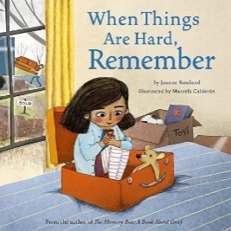
“A seed falls to the ground. A child moves away from home. Can life bloom in a new place? With gentle storytelling and poetic language, Joanna Rowland explores what it means to have hope—hope that things will get better, hope that you are cared for even when things are hard, and hope that new growth is waiting to burst forth, just around the corner.”
Video Link: https://www.youtube.com/watch?v=LcL_0ngvNQU (3:10)

3.2: Once Upon a Memory by Nina Laden (Author), Renata Liwska (Illustrator) 2013
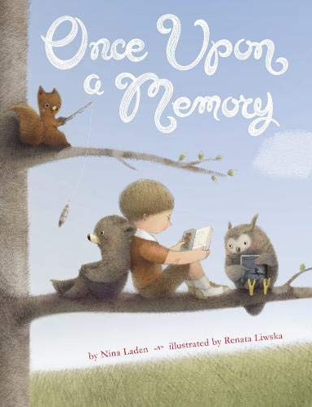
“Does a feather remember it once was a bird? Does a book remember it once was a word? A boy is swept away to a world where fantasy and reality come together in surprising and playful ways. From the cake that once was grain to the ocean that once was rain, whimsical before and after scenes offer readers a peek at the world as seen through the eyes of a curious child.”
Video Link: https://www.youtube.com/watch?v=-rK_T709oQw (4:38) (speaker volume is low)

3.3: Memory Jar by Vera Brosgol (2021)
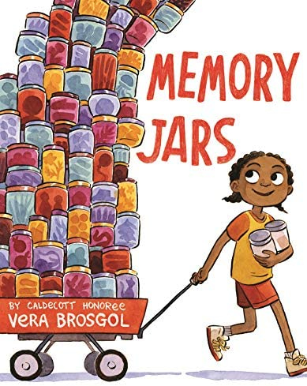
“Freda is devastated when she can’t eat all the delicious blueberries she’s picked. She has to wait a whole year before they’re back, and she doesn’t want to lose them! Then Gran reminds her that they can save blueberries in a jar, as jam. So, Freda begins to save all her favorite things. But it turns out that saving everything also means she can’t enjoy anything, and Freda realizes that some things are best saved as memories.”
Video Link: https://www.youtube.com/watch?v=-rK_T709oQw (5:59)

3.4: The Map of Good Memories by Fran Nuño (Author), Zuzanna Celej (Illustrator), and Jon Brokenbrow (Translator) 2017
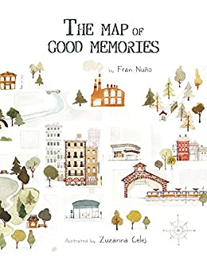
“Zoe had lived in the city since she was born. She knew every building, every park, every corner of the city. But the war broke out and she, like many others, had to say goodbye to her home and leave without knowing when she might return. Zoe has so many good memories of her city… Her grandparents’ house, a shelter full of dreams and games, her old school, where she met her friends and loved learning new things. Not to mention the downtown park, where She’d spent many Sunday mornings there, playing on the swings, listening to people playing music, and riding her bike.
“Almost about to leave, Zoe spread the map of the city on a table and started to mark all the places where she was really happy, with the certainty that they will always accompany her.”
Video Link: https://www.youtube.com/watch?v=LCwF0bQyOlw (4:38)

3.5: The Memory Coat by Elvira Woodruff (Author) and Michael Dooling (Illustrator) (1999)
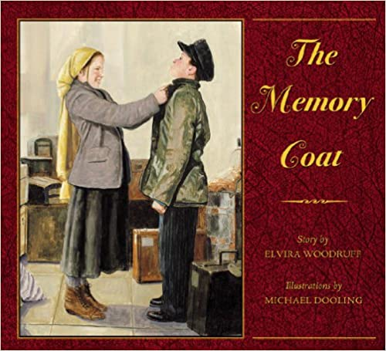
“This moving story of a Jewish family’s immigration to American from Russia may be jeopardized by a young cousin’s bond with a worn-out coat. At the turn-of-the century, a Jewish family must leave Russia when the Cossacks raid the country. Grandma Bubba tries to convince Grisha, her grandson, to leave behind an old coat that might prevent him from being accepted at Ellis Island upon the family’s arrival in America. Grisha refuses since the coat is lined with wool from the coat of his deceased mother. The family begins their transatlantic journey, but when they arrive at Ellis Island, Grisha is threatened with deportation until his cousin Rachel comes up with a plan to save him. Woodruff’s historical detail is based on research she discovered at the Ellis Island museum. A fine introduction to European immigration for young readers ages four to eight. A moving example of familial love.”
Video Link: https://www.youtube.com/watch?v=ShKyk_MEzbw (12:10)

Memory Loss
3.6: The Remember Balloons by Jessie Oliveros (Author) and Dana Wulfekotte (Illustrator) (2018)
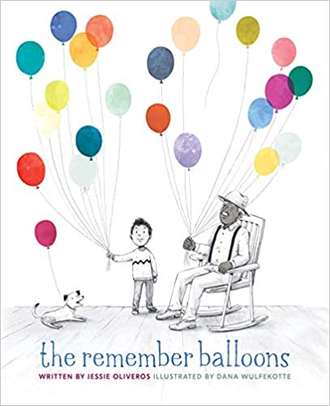
“James’s Grandpa has the best balloons because he has the best memories. He has balloons showing Dad when he was young and Grandma when they were married. Grandpa has balloons about camping and Aunt Nelle’s poor cow. Grandpa also has a silver balloon filled with the memory of a fishing trip he and James took together.
“But when Grandpa’s balloons begin to float away, James is heartbroken. No matter how hard he runs, James can’t catch them. One day, Grandpa lets go of the silver balloon—and he doesn’t even notice!
“Grandpa no longer has balloons of his own. But James has many more than before. It’s up to him to share those balloons, one by one.”
Video Link: https://www.youtube.com/watch?v=TKRf35ETahI (9:16)

3.7: Wilfrid Gordon Macdonald Partridge by Mem Fox (Author) and Julie Vivas (Author) (1987)
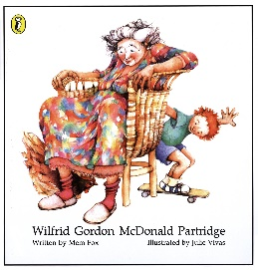
“Wilfrid Gordon McDonald Partridge is a small boy who has a big name—and that’s why he likes Miss Nancy Alison Delacourt Cooper because she has too. So, when he finds Miss Nancy has lost her memory, Wilfrid determines to discover what memories are so he can find it for her.”
Video Link: https://www.youtube.com/watch?v=3HS3udd4HSQ (4:38)

Grief

3.8: The Memory Box: A Book About Grief by Joanna Rowland, author and Thea Baker, illustrator (2017)
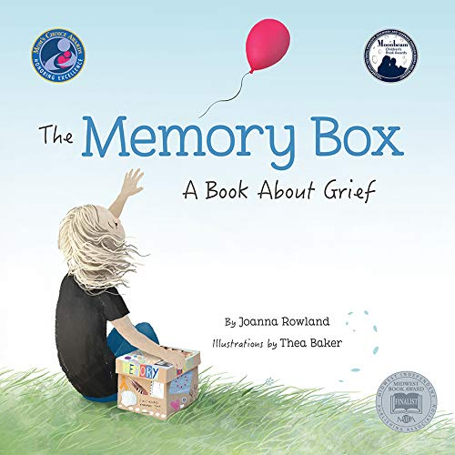
“‘I’m scared I’ll forget you...’ From the perspective of a young child, Joanna Rowland artfully describes what it is like to remember and grieve a loved one who has died. The child in the story creates a memory box to keep mementos and written memories of the loved one, to help in the grieving process. Heartfelt and comforting, The Memory Box will help children and adults talk about this very difficult topic together. The unique point of view allows the reader to imagine the loss of any they have loved - a friend, family member, or even a pet. A parent guide in the back includes information on helping children manage the complex and difficult emotions they feel when they lose someone they love, as well as suggestions on how to create their own memory box.”

Video Link: https://www.youtube.com/watch?v=mF-Izj1668I (4:15)

How to make a memory box: https://www.youtube.com/watch?v=Doz2FsyvqTVE (4:15)

3.9: Grandpa’s Stories by Joseph Coelho (Author) and Allison Colpoys (Illustrator) (2019)
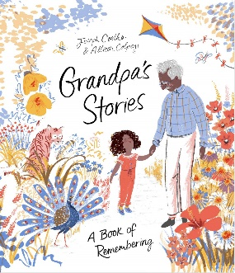
“One young girl reflects on a year with her beloved grandpa. She remembers the fields and parks they explored in the springtime and the old toys they fixed up in the summer. She remembers the handmade gifts they exchanged in the fall and the stories Grandpa told by the fi re each winter. But this year, the girl must say good-bye to Grandpa. In the face of her grief, she is determined to find a way to honor him. She decides to record her Grandpa’s stories in the notebook he made for her and carry Grandpa with her as she grows. An honest and relatable depiction of loss, Grandpa’s Stories celebrates life and the ways in which love lives on.”
Video Link: https://www.youtube.com/watch?v=_4K_K07a8LM (4:29)

3.10: Map of Memory Lane by Francesca Lynn Arnoldy (Author) and Young Ju Kim (Illustrator) (2021)
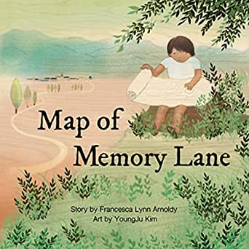
“Children are naturally curious. Sometimes they have BIG questions.
“When Lee asks Nana if she will live forever, Nana explains how people can visit a special place when they want to remember someone—a place where memories are treasured. Map Of memory Lane is a heartwarming story that gently introduces the topic of loss while celebrating the simple moments we share.
Video Link: https://www.youtube.com/watch?v=zwQ9yRUIqDU (4:50)

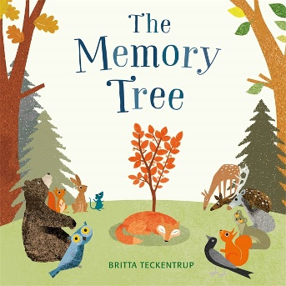
3.11: The Memory Tree by Britta Teckentrup (2014)
“Fox has lived a long and happy life in the forest, but now he is tired. He lies down in his favorite clearing, and falls asleep forever. Before long, Fox’s friends begin to gather in the clearing. One by one, they tell stories of the special moments that they shared with Fox. And so, as they share their memories, a tree begins to grow, becoming bigger and stronger with each memory, sheltering and protecting all the animals in the forest, just as Fox did when he was alive.”
Video Link: https://www.youtube.com/watch?v=BHX8dZjhJMM&t=57s (5:22)

3.12: The Memory String by Eve Bunting (Author) and Ted Rand (Illustrator) (2015)
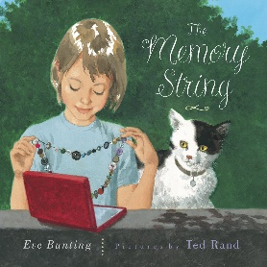
“Each button on Laura’s memory string represents a piece of her family history. The buttons Laura cherishes the most belonged to her mother—a button from her prom dress, a white one off her wedding dress, and a single small button from the nightgown she was wearing on the day she died. When the string breaks, Laura’s new stepmother, Jane, is there to comfort Laura and search for a missing button, just as Laura’s mother would have done. But it’s not the same—Jane isn’t Mom. In Eve Bunting’s moving story, beautifully illustrated by Ted Rand, Laura discovers that a memory string is not just for remembering the past: it’s also for recording new memories.”
Video Link: https://www.youtube.com/watch?v=RFuG-NCLAiI (11:43)

Story
3.13: I Am a Story by Dan Yaccarino (2016)
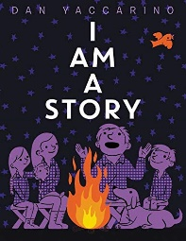
“From cave drawings to the invention of the printing press to our digital age, discover how a story has been told in many different ways from the past to today. It’s always been around, making us happy, sad, excited, or scared and bringing people together. With simple text and delightful illustrations, Dan Yaccarino reminds us of the power of story.”
Video Link: https://www.youtube.com/watch?v=NZ8k5F_DnO0 (3:11)

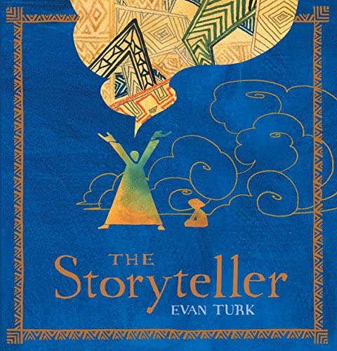
3.14: The Storyteller by Evan Turk (2016)
“Long, long ago, like a pearl around a grain of sand, the Kingdom of Morocco formed at the edge of the great, dry Sahara. It had fountains of cool, refreshing water to quench the thirst of the desert, and storytellers to bring the people together.
“But as the kingdom grew, the people forgot the dangers of the desert, and they forgot about the storytellers, too. All but one young boy, who came to the Great Square for a drink and found something that quenched his thirst even better: wonderful stories. As he listened to the last storyteller recount the Endless Drought, and the Glorious Blue Water Bird, he discovered the power of a tale well told.”
Video Link: https://www.youtube.com/watch?v=tewAB8yAvu0 (12:48)

3.15: Once Upon a Winter Day by Liza Woodruff (2020)
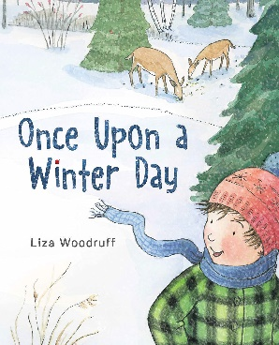
“Milo wants a story, but his mom is too busy to entertain him. Instead, she encourages him to go out and play in the snow. At first, Milo is disappointed - he doesn’t want to play outside, he wants a story.
“But when he starts to follow a trail of mouse-prints, he discovers signs of activity all around, prompting him to ask, “What happened here?” Before long, he’s using his imagination -- depicted in lush wordless spreads that capture the vividness of Milo’s fantasies -- to fill in the gaps. By the time Milo comes home, he’s the one with stories to tell.”
Video Link: https://www.youtube.com/watch?v=LH_y9lpsK3k (4:34)

3.16: Telling Stories Wrong by Gianni Rodari (Author) and Beatrice Alemagna (Illustrator) (2022)
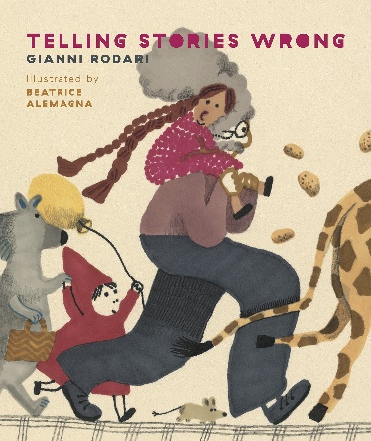
“‘Once upon a time, there was a little girl called Little Yellow Riding Hood—’ “Not yellow! It’s Red Riding Hood!’ So begins the story of a grandpa playfully recounting the well-known fairytale—or his version, at least to his granddaughter. Try as she might to get him back on track, Grandpa keeps on adding things to the mix, both outlandish and mundane! The end result is an unpredictable tale that comes alive as it’s being told, born out of imaginative play and familial affection. This spirited picture book will surprise and delight from start to finish, while reminding readers that storytelling is not only a creative act of improvisation and interaction, but also a powerful pathway for connection and love.
Video Link: https://www.youtube.com/watch?v=ebwDNc4l9ck (4:02)

3.17: Once Upon a Baby Brother by Sarah Sullivan (2010)
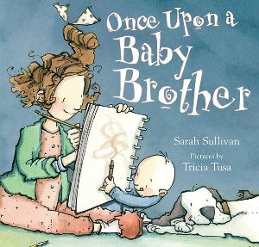
“Lizzie loves to make up stories and tell them to anyone and everyone, even though now that her annoying baby brother, Marvin, has joined the family, no one has time to listen. She’s so full of ideas, it seems like nothing can stop her. And then one day, something does. What’s a star writer to do? Lizzie finds inspiration where she least expects it….”
Video Link: https://www.youtube.com/watch?v=pPQFiN5Jyog (11:42)

Black Experience
3.18: Circle Unbroken by Margot Theis Raven (Author) and E. B. Lewis (Illustrator) (2007)
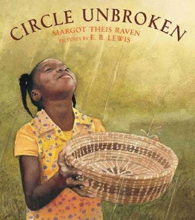
“As she teaches her granddaughter to sew a traditional sweetgrass basket, a grandmother weaves a story, going back generations to her grandfather’s village in faraway Africa. There, as a boy, he learned to make baskets so tightly woven they could hold the rain. Even after being stolen away to a slave ship bound for America, he remembers what he learned and passes these memories on to his children - as they do theirs.”
Video Link: https://www.youtube.com/watch?v=fFWu9QKbzFc (8:36)

3.19: The 1619 Project: Born on the Water by Nikole Hannah-Jones and Renée Watson (Authors) and Nikkolas Smith (Illustrator) 2021
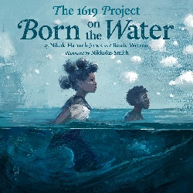
“The 1619 Project’s lyrical picture book in verse chronicles the consequences of slavery and the history of Black resistance in the United States….
“A young student receives a family tree assignment in school, but she can only trace back three generations. Grandma gathers the whole family, and the student learns that 400 years ago, in 1619, their ancestors were stolen and brought to America by white slave traders.
“But before that, they had a home, a land, a language. She learns how the people said to be born on the water survived.”
Video Link: https://www.youtube.com/watch?v=rG4SZA41jjg (16:50)

Obon
3.20: Suki’s Kimono by Chieri Uegaki (Author) and Stéphane Jorisch (Illustrator) (2005)
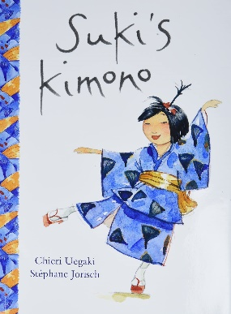
“Suki’s favorite possession is her blue cotton kimono. A gift from her obachan, it holds special memories of her grandmother’s visit last summer. And Suki is going to wear it on her first day back to school --- no matter what anyone says.When it’s Suki’s turn to share with her classmates what she did during the summer, she tells them about the street festival she attended with her obachan and the circle dance that they took part in. In fact, she gets so carried away reminiscing that she’s soon humming the music and dancing away, much to the delight of her entire class! Filled with gentle enthusiasm and a touch of whimsy, Suki’s Kimono is the joyful story of a little girl whose spirit leads her to march—and dance—to her own drumbeat.”
“…The circle dance shown in these pictures is called Bon Odori. Bon [aka Obon] is a traditional festival that takes place every August in commemoration of deceased family members and ancestors. The festival includes dance performances, in which dancers wear cotton kimonos just like in this picture. Some dances can be very large and include hundreds of people dancing and celebrating.”
Video Link: https://www.youtube.com/watch?v=JJIu7yrw-mw (9:15)
Teaching Guide: https://www.kidscanpress.com/wp-content/uploads/2022/04/SukisKimono_0874_teaching-1.pdf
For more information about Bon/Obon see 9.1 below.

…… Dia de los Muertos
3.21: The Remembering Day / El dia de los muertos by Pat Mora (Author) and Robert Casilla (Illustrator) (2015)
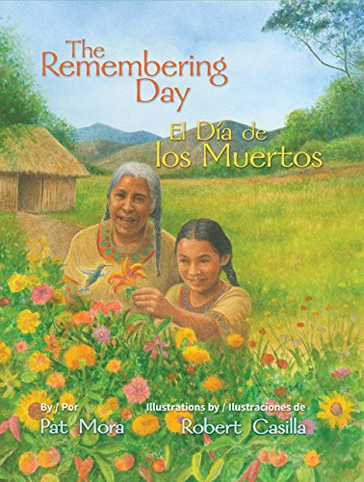
“Long, long, long ago, Bella and her grandmother Mamá Alma admired their vegetable garden. They liked gardening together. They grew sunflowers and lilies too, and chatted with lizards and hummingbirds. They walked around the flowers and vegetables holding hands, something they had done frequently since Bella was a baby. As her grandmother aged, Bella helped her to walk. “Every year, I need your help more and more,” said Mamá Alma.
“Sitting on their favorite rock, they remembered how Mamá Alma carried Bella to show her the sun and everything that grew in its powerful rays: trees, cacti, corn and flowers. The oldest and wisest woman in the village, she taught her granddaughter to sing, tell stories and weave. Mamá Alma is pleased that Bella has become the best healer in the village, the one everyone comes to for help with a sick bird or a stomach ache. Mamá Alma tells her granddaughter to remember their happy times together and to plan an annual “remembering day,” a special time to think about her when she is gone.
“In this special bilingual picture book for children, acclaimed author Pat Mora creates an origin myth in which she imagines how the Mexican custom of remembering deceased loved ones—El día de los muertos or the Day of the Dead—came to be. With tender illustrations by Robert Casilla that depict Bella and Mamá Alma’s loving relationship, this book will encourage children to honor loved ones, whether by writing stories and poems or creating their own remembering place.”
Video Link: https://www.youtube.com/watch?v=fwImunKUAAo (8:47)

3.22: Maria Molina and the Days of the Dead by Kathleen Krull (Author) and Enrique Sanchez (Illustrator) (1994)
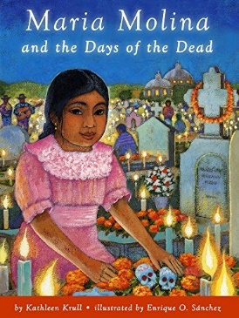
“In Mexico, Maria and her family gather to honor her baby brother, Pablo, on October 31, Los Días de los Muertos, the first of The Days of the Dead. The next night, they honor her Grandmother. The cemetery is filled with candles, fireworks, music and dancing, for after the spirits have gone away, you get to eat all the good food! The next year is sad because Maria’s mother and father travel north to find work, leaving Maria and her other brother with their aunt and uncle. Maria worries how they can honor Pablo and Abuela. Includes a recipe for pan de los muertos.”
Video Link: https://www.youtube.com/watch?v=IFlJusZDNCo (8:42)

Samhain
3.23: Rupert’s Tales: The Wheel of the Year - Samhain, Yule, Imbolc, and Ostara by Kyrja (Author) and (Illustrator) (2012)
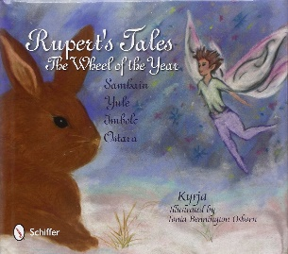
“Come along with Rupert the rabbit as he again travels through the Wheel of the Year. In this second book of adventures, he learns about tolerance, respect, and acceptance, and discovers how people celebrate seasonal holidays in the forest where he lives. The tales (one for each season – Samhain, Yule, Imbolc, and Ostara) set the stage for our furry friend to understand the importance of the seasons and that remembering love and laughter is always wise. He learns about decorations, songs, symbols, and how important the sun and its warmth really are. Join Rupert as he meets a new fairy friend and lots of girls and boys. Find out how someone very special steals Rupert’s heart! Perfect for teaching sacred Pagan practices and beliefs to young children being raised within varied traditions. Rupert’s Tales are stories for all children, everywhere!”
Video Link: https://www.youtube.com/watch?v=roikQsFuMYU (15:

Memorial Day / Remembrance Day / Veteran’s Day / Vietnam Memorial
3.24: A Day for Rememberin’: Inspired by the True Events of the First Memorial Day by Leah Henderson (Author) and Floyd Cooper (Illustrator) (2021)
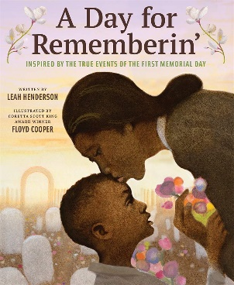
“Today is a special day. Eli knows it’s important if he’s allowed to miss one second of school, his ‘hard-earned right.’
“Inspired by true events and told through the eyes of a young boy, this is the deeply moving story about what is regarded as the first Memorial Day on May 1, 1865. Eli dresses up in his best clothes, Mama gathers the mayflowers, Papa straightens his hat, and together they join the crowds filling the streets of Charleston, South Carolina, with bouquets, crosses, and wreaths. Abolitionists, missionaries, teachers, military officers, and a sea of faces Black, Brown, and White, they march as one and sing for all those who gave their lives fighting for freedom during the Civil War.
“With poignant prose and celebratory, powerful illustrations, A Day for Rememberin’ shines light on the little-known history of this important holiday and reminds us never to forget the people who put their lives on the line for their country.”
Video Link: https://www.youtube.com/watch?v=7NsX_l2FgH8 (10:59)

3.25: Let’s Celebrate Memorial Day by Barbara deRubertis (Author) (2016)
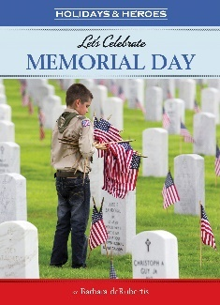
“On the last Monday of May, when spring flowers are in bloom and summer is just around the corner, we pause to remember all the brave men and women in our Armed Forces who died while protecting our country, our freedoms, and us.”
Video Link: https://www.youtube.com/watch?v=QsgFENztHKI (12:31)

3.26: Memorial Day Surprise by Theresa Martin Golding (Author) and Alexandra Artigas (Illustrator) (2004)
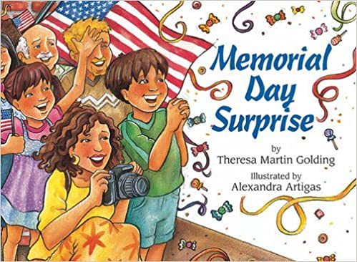
“It’s Memorial Day and Marco and Mama are going to see the parade. On their way, they pass Marco’s grandfather’s house. They usually stop to see Grandfather, but today Mama is in a rush because she has promised Marco a surprise. Marco can’t imagine what the surprise might be. Could it be the marching band? The fire engines? The candy tossed to the crowd by a woman dressed as the Statue of Liberty? Mama promises that it will be a better surprise than candy. As the parade goes by, Marco wishes his grandfather were with him to enjoy it. Then, marching down the street, come the veterans, wearing uniforms and shiny medals. But look! Who is that leading them? Marco never imagined the kind of surprise in store for him.”
Video Link: https://www.youtube.com/watch?v=QaHl7BhGFN8 (7:47)

3.27: A Poppy Is to Remember by Heather Patterson (Author) and Ron Lightburn (Illustrator) (2004)
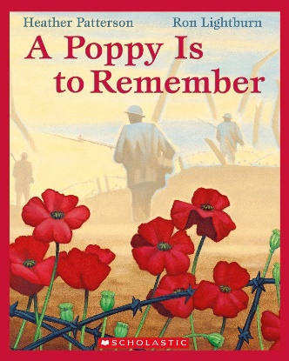
“How did the bright red poppy that we all wear in November become Canada’s symbol of honoring those who fought for our freedom on Remembrance Day? Moving text coupled with stunning illustrations …explain the symbolism behind the poppy.
“A bonus for teachers is the five-page spread all about the poem, In Flanders Fields, Canada’s wartime and peacekeeping endeavors, and the adoption of the poppy as our Remembrance Day emblem.”
Video Link: https://www.youtube.com/watch?v=eJZQVhaxwH4 (7:13)

3.28: The Poppy Lady: Moina Belle Michael and Her Tribute to Veterans by Barbara E. Walsh (Author) and Layne Johnson (Illustrator) (2012)
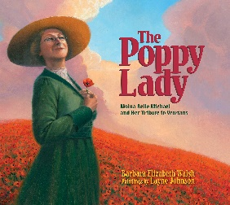
“When American soldiers entered World War I, Moina Belle Michael, a schoolteacher from Georgia, knew she had to act. Some of the soldiers were her students and friends. Almost single-handedly, Moina worked to establish the red poppy as the symbol to honor and remember soldiers. And she devoted the rest of her life to making sure the symbol would last forever. Thanks to her hard work, that symbol remains strong today.”
Video Link: https://www.youtube.com/watch?v=O9jIL2Q6o-0 (12:36)

3.29: America’s White Table by Margot Theis Raven (Author) and Mike Benny (Illustrator) (2005)
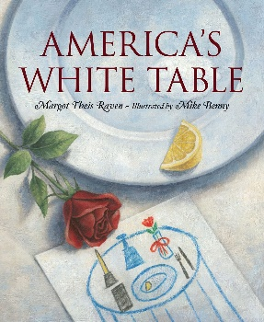
“The White Table is set in many mess halls as a symbol for and remembrance to service members fallen, missing, or held captive in the line of duty. Solitary and solemn, it is the table where no one will ever sit. As a special gift to her Uncle John, Katie and her sisters are asked to help set the white table for dinner. As their mother explains the significance of each item placed on the table Katie comes to understand and appreciate the depth of sacrifice that her uncle, and each member of the Armed Forces and their families, may be called to give. It was just a little white table... but it felt as big as America when we helped Mama put each item on it and she told us why it was so important. ‘We use a Small Table, girls,’ she explained first, ‘to show one soldier’s lonely battle against many. We cover it with a White Cloth to honor a soldier’s pure heart when he answers his country’s call to duty.’ ‘We place a Lemon Slice and Grains of Salt on a plate to show a captive soldier’s bitter fate and the tears of families waiting for loved ones to return,’ she continued. ‘We push an Empty Chair to the table for the missing soldiers who are not here....’”
Video Link: https://www.youtube.com/watch?v=DlEVByFVg4w (6:50)

3.30: The Wall by Eve Bunting (Author) and Ronald Himler (Illustrator) (1992)
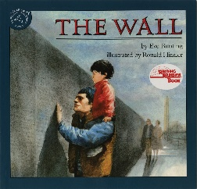
“This book tells the story of a father and son visiting the Vietnam Memorial Wall together to find the name of their father/grandfather.”
Video Link: https://www.youtube.com/watch?v=yijiNhcwDAQ (7:05)

9/11
3.31: Branches of Hope: The 9/11 Survivor Tree by Ann Magee (Author) and Nicole Wong (Illustrator) (2021)
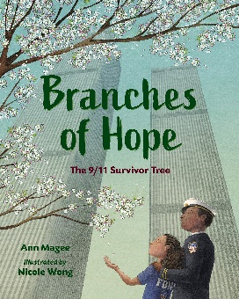
In this moving tribute to a city and its people, a wordless story of a young child accompanies the tree’s history. As the tree heals, the girl grows into an adult, and by the 20th anniversary of 9/11, she has become a firefighter like her first-responder uncle. A life-affirming introduction to how 9/11 affected the United States and how we recovered together.
Video Link: https://www.youtube.com/watch?v=sSZ1U4diYW0 (5:10)

Columbus Day
3.32: Christopher the Ogre Cologre, It’s Over! (The Real History of Christopher Columbus) by Dr. Oriel Maria Siu (Author) and Víctor Zúñiga (Illustrator) (2021)
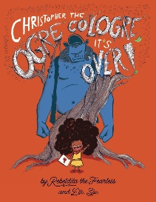
“GIGANTIC LIES meet EMPOWERING TRUTHS in this masterfully written, family friendly book finally bringing children, parents, and educators the real history of Christopher Columbus. By scholar and educator, Dr. Siu.”
Video Link: https://www.youtube.com/watch?v=ngN_wyIbvc4 (4:41, story begins at 1:22)

Thanksgiving
3.33: Keepunumuk: Weeâchumun’s Thanksgiving by Danielle Greendee, Anthony Perry & Alexis Bunten (Authors) and Gary Meeches Sr (Illustrator) (August 2022)
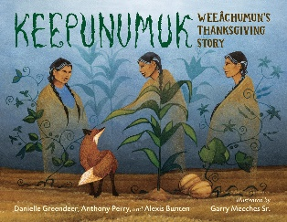
“In this Wampanoag story told in a Native tradition, two kids from the Mashpee Wampanoag tribe learn the story of Weeâchumun (corn) and the first Thanksgiving.
“The Thanksgiving story that most Americans know celebrates the Pilgrims. But without members of the Wampanoag tribe who already lived on the land where the Pilgrims settled, the Pilgrims would never have made it through their first winter. And without Weeâchumun (corn), the Native people wouldn’t have helped.
“In important picture book honoring both the history and tradition that surrounds the story of the first Thanksgiving.”
“Wispy, dreamlike illustrations complement this tale of the first Thanksgiving from a Wampanoag perspective. Weeâchumun, the wise corn, and her sisters, Beans and Squash, are considered the three sisters of the harvest. When Weeâchumun sees the settlers arrive, she tasks Fox to watch them through the winter. When spring returns, Fox reports the newcomers are hungry and struggling, and the sisters send the First Peoples to their aid, setting history into motion.”
In Conversation with the Creators of Keepunumuk, Video Link: https://www.youtube.com/watch?v=v7vwa6IHPk8 (22:13) Author Danielle Greendeer is a Mashpee Wampanoag citizen. Author Anthony Perry is a Chickasaw citizen. Author Alexis Bunten is Alaskan Native (Yu’pik & Unangan). Canadian illustrator Garry Meeches Sr. is an Anishinaabe citizen.
Text of interview with the authors: https://www.forewordreviews.com/articles/article/four-native-american-creators-weave-together-the-story-of-keepunumuk-the-time-of-harvest/
Down to Earth: A Review of Keepunumuk: Weeâchumun’s Thanksgiving Story: https://butlerspantry.org/2022/07/14/down-to-earth-a-review-of-keepunumuk-weeachumuns-thanksgiving-story/ (excellent overview)

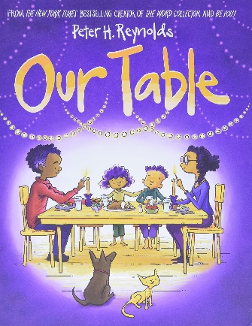
3.34: Our Table by Peter H. Reynolds (Author, Illustrator) 2021
“Violet longs for the time when her family was connected: before life, distractions, and technology pulled them all away from each other. They used to gather at the table, with food and love, to make memories, share their lives, and revel in time spent together. But now her family has been drifting apart, and with nobody to gather around it, the table grows smaller and smaller.
“Can Violet remind her family of the warmth of time spent together, and gather around the table once more?
“A mystical fable that feels at once timeless and utterly of the present moment, Our Table is renowned, bestselling creator Peter H. Reynolds at his best. Exquisite, expressive watercolor tells a tender story, growing from monochrome into luscious, joyful color as Violet’s family is reunited around the beloved table. An ode to traditions that unite families, Our Table brings readers together with a universal message of gratitude.”
Video Link: https://www.youtube.com/watch?v=tEequSLEiXQ (3:15)

Indigenous Peoples’ Stories
3.35: We Are Grateful: Otsaliheliga by Traci Sorell (Author) and Frane Lessac (Illustrator) (2018)
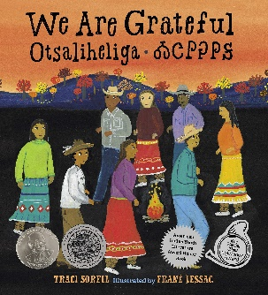
“The Cherokee community is grateful for blessings and challenges that each season brings. This is modern Native American life as told by an enrolled citizen of the Cherokee Nation.
“The word otsaliheliga (oh-jah-LEE-hay-lee-gah) is used by members of the Cherokee Nation to express gratitude. Beginning in the fall with the new year and ending in summer, follow a full Cherokee year of celebrations and experiences. Written by a citizen of the Cherokee Nation, this look at one group of Native Americans is appended with a glossary and the complete Cherokee syllabary, originally created by Sequoyah.
Video Link: https://www.youtube.com/watch?v=zSNl3108aHA (5:31)

3.36: We Are Still Here!: Native American Truths Everyone Should Know by Traci Sorell (Author) and Frane Lessac (Illustrator) (2021)
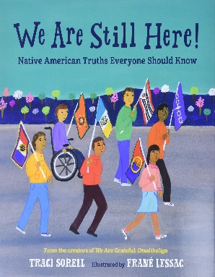
“Too often, Native American history is treated as a finished chapter instead of relevant and ongoing. This companion book to the award-winning We Are Grateful: Otsaliheliga offers readers everything they never learned in school about Native American people’s past, present, and future. Precise, lyrical writing presents topics including: forced assimilation (such as boarding schools), land allotment and Native tribal reorganization, termination (the US government not recognizing tribes as nations), Native urban relocation (from reservations), self-determination (tribal self-empowerment), Native civil rights, the Indian Child Welfare Act (ICWA), religious freedom, economic development (including casino development), Native language revival efforts, cultural persistence, and nationhood.”
Video Link: https://www.youtube.com/watch?v=Nm8UXaV-EZo (17:07, story begins at 4:56)

3.37: We Are Water Protectors by Carole Lindstrom (Author) and Michaela Goade (Illustrator) (2020)
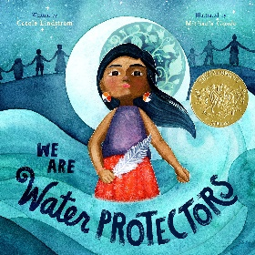
“Inspired by the many Indigenous-led movements across North America, We Are Water Protectors issues an urgent rallying cry to safeguard the Earth’s water from harm and corruption….
“‘Water is the first medicine. It affects and connects us all . . .’
“When a black snake threatens to destroy the Earth
And poison her people’s water, one young water protector
Takes a stand to defend Earth’s most sacred resource.”
Video Link: https://www.youtube.com/watch?v=tJLnvSjvkus (3:52)

3.38: The People Shall Continue by Simon J Ortiz (Author) and Sharol Graves (Illustrator) (2017)
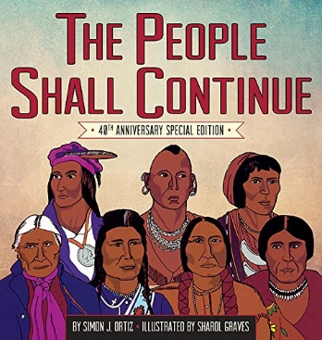
“Told in the rhythms of traditional oral narrative, this powerful telling of the history of the Native/Indigenous peoples of North America recounts their story from Creation to the invasion and usurpation of Native lands. As more and more people arrived, The People saw that the new men did not respect the land. The People witnessed the destruction of their Nations and the enslavement of their people. The People fought hard, but eventually agreed to stop fighting and signed treaties.
“Many things changed and became more difficult, but The People continued to farm and create crafts. They remembered and told their children, ‘You are Shawnee. You are Lakota. You are Pima. You Acoma…. You are all these Nations of the People.’ The People held onto their beliefs and customs and found solidarity with other oppressed people. And despite struggles against greed, destruction of their lands, and oppression, The People persisted.
Video Link: https://www.youtube.com/watch?v=-MFHfG-AWTY (14:12)

3.39: Fry Bread: A Native American Family Story by Kevin Noble Maillard (Author) and Juana Martinez-Neal (Illustrator) (2019)
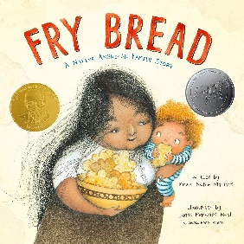
“Told in powerful verse…, Fry Bread is an evocative story about family, history, culture, and traditions, new and old.”
Video Link: https://www.youtube.com/watch?v=MibEeGiFThM (4:45)

Residential Schools in the US & Canada
3.40: Remembering Green, An Ojibwe Girl s Tale by Lisa Gammon Olson (Author) and Lauren Rutledge (Illustrator) (2020)
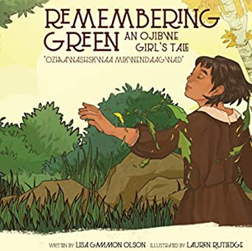
“Remembering Green features Wenonah, an Ojibwe girl from the Lac Du Flambeau tribe in northern Wisconsin in the early 1900’s during the forced assimilation period of Native American children into the white culture. It was a dark time in our history for Indigenous people as they were stripped of their native heritage and culture and sent to boarding schools where they were forced to forget everything they knew about their lives as Native Americans. Wenonah and her Grandfather will discover ways that Wenonah can remember her Ojibwe heritage even though the world is changing for them all.”
Video Link: https://www.youtube.com/watch?v=J-1KfrXhQQo
(10:38)

3.41: Jim Thorpe’s Bright Path by Joseph Bruchac (Author) and Nelson;S. D. (Illustrator) 2004
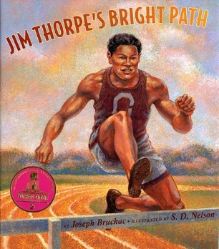
“Jim Thorpe’s parents knew he was special from the day he was born. When they held him and his twin brother, Charlie, his mother noticed how the light shone on the road to their cabin. She gave Jim an extra name: Wa\-Tha\-Huck, or Bright Path.
“Jim developed his athletic skills early on, playing outdoors and hunting with his father and brother. But when Jim was sent to Indian Boarding Schools, he was confined to stiff uniforms and strict rules. While he struggled in academics, he always excelled in sports. As Jim moved from school to school over the years, overcoming family tragedies, he always remembered the encouragement of his brother and the words of his father that the white man’s knowledge was necessary for him and his people to survive.
“Jim Thorpe’s Bright Path takes a fresh look at a world\-renowned sports hero and allows the reader to meet the person behind the celebrated athlete. Thorpe’s story of determination and perseverance will resonate with every child who dreams of finding his or her own bright path.”
Video Link: https://www.youtube.com/watch?v=UcQlS9NQ0wU (19:32)
Video: Akapamata - The Real Story of Jim Thorpe, https://www.youtube.com/watch?v=U5tUD2Uj3Yk (3:24)

3.42: The Orange Shirt Story by Phyllis Webstad (Author) and Brock Nicol (Illustrator) (2018)
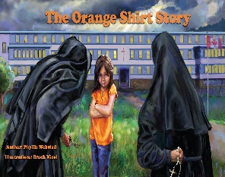
“This is the true story of Phyllis and her orange shirt. It is also the true story of Orange Shirt Day [on September 30] (an important day of remembrance for First Nations and non First Nations peoples). When Phyllis Webstad (nee Jack) turned six, she went to the residential school for the first time. On her first day at school, she wore a shiny orange shirt that her Granny had bought for her, but when she got to the school, it was taken away from her and never returned.”
Video Link: https://www.youtube.com/watch?v=VUsoDAPE8O0 (13:22)

3.43: Stolen Words by Melanie Florence (Author) and Gabrielle Grimard (Illustrator) (2017)
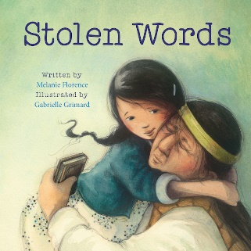
“The story of the beautiful relationship between a little girl and her grandfather. When she asks her grandfather how to say something in his language – Cree – he admits that his language was stolen from him when he was a boy. The little girl then sets out to help her grandfather find his language again. This sensitive and warmly illustrated picture book explores the intergenerational impact of the residential school system that separated young Indigenous children from their families. The story recognizes the pain of those whose culture and language were taken from them, how that pain is passed down, and how healing can also be shared.”
Video Link: https://www.youtube.com/watch?v=GJxpzyVRc7w&t=35s (6:34)

3.44: When I Was Eight by Christy Jordan-Fenton & Margaret Pokiak-Fenton (Authors) and Gabrielle Grimard (Illustrator) (2013)
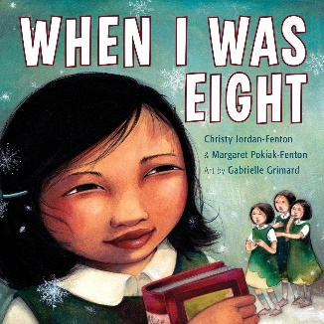
“Based on bestselling memoir Fatty Legs…. Olemaun is eight and knows a lot of things. But she does not know how to read. Ignoring her father’s warnings, she travels far from her Arctic home to the [Canadian residential] … school to learn. The nuns at the school call her Margaret. They cut off her long hair and force her to do menial chores, but she remains undaunted. Her tenacity draws the attention of a black-cloaked nun who tries to break her spirit at every turn. But the young girl is more determined than ever to learn how to read. Based on the true story of Margaret Pokiak-Fenton, and complemented by stunning illustrations, When I Was Eight makes her bestselling Fatty Legs accessible to younger readers. Now they, too, can meet this remarkable girl who reminds us what power we hold when we can read.”
Video Link: https://www.youtube.com/watch?v=K2f668fX0Iw (12:23)

3.45: I Am Not a Number by Jenny Kay Dupuis & Kathy Kacer (Authors) and Gillian Newland (Illustrator) (2016)
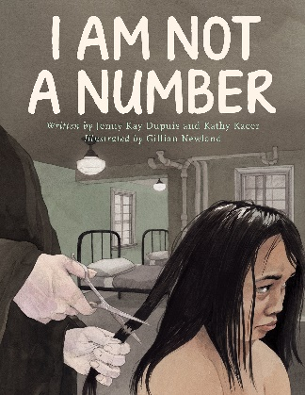
“When eight-year-old Irene is removed from her First Nations family to live in a residential school she is confused, frightened, and terribly homesick. She tries to remember who she is and where she came from, despite the efforts of the nuns who are in charge at the school and who tell her that she is not to use her own name but instead use the number they have assigned to her. When she goes home for summer holidays, Irene’s parents decide never to send her and her brothers away again. But where will they hide? And what will happen when her parents disobey the law? Based on the life of co-author Jenny Kay Dupuis’ grandmother, I Am Not a Number is a hugely necessary book that brings a terrible part of Canada’s history to light in a way that children can learn from and relate to.”
Video Link: https://www.youtube.com/watch?v=p2MP5ioGHAc (24:55)

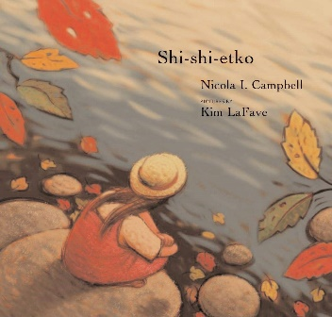
3.46: Shi-shi-etko by Nicola I. Campbell, author and Kim LaFave, illustrator (2005)

“Shi-shi-etko just has four days until she will have to leave her family and everything she knows to attend residential school. She spends her last precious days at home treasuring and appreciating the beauty of her world — the dancing sunlight, the tall grass, each shiny rock, the tadpoles in the creek, her grandfather’s paddle song. Her mother, father, and grandmother, each in turn, share valuable teachings that they want her to remember. Shi-shi-etko carefully gathers her memories for safekeeping.

“LaFave’s richly hued illustrations complement Campbell’s gently moving and poetic account of a child who finds solace around her, even though she is on the verge of great loss — a loss that native people have endured for generations because of Canada’s residential schools system.”

Video Link: https://www.youtube.com/watch?v=Ha6vMDGmzYo (7:18)

Film of story: https://www.youtube.com/watch?v=tKErhCGjSDE (6:05)

Song about story: https://www.youtube.com/watch?v=JRu0IT0Pd50 (3:16)

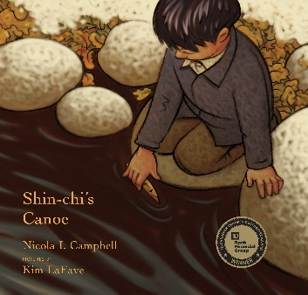
3.47: Shin-chi’s Canoe by Nicola I. Campbell, author and Kim LaFave, illustrator (2005)

“When they arrive at school, Shi-shi-etko reminds Shinchi, her six-year- old brother, that they can only use their English names and that they can’t speak to each other. For Shinchi, life becomes an endless cycle of church mass, school, and work, punctuated by skimpy meals. He finds solace at the river, clutching a tiny cedar canoe, a gift from his father, and dreaming of the day when the salmon return to the river — a sign that it’s almost time to return home. This poignant story about a devastating chapter in First Nations history is told at a child’s level of understanding.”

Video Link: https://www.youtube.com/watch?v=ktV1CdIUEIY (7:34)

Other
3.48: Please Try to Remember the First of Octember! by Dr. Seuss writing as Theodore Lesieg (Author) and Art Cummings (Illustrator) (1977)
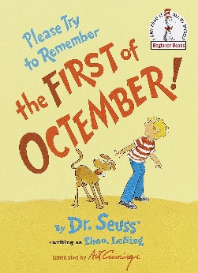
“Dr. Seuss imagines a day when all your wishes come true in this classic Beginner Book. Octember the First is the day on which all your most outlandish wishes come true. If March is too dusty and April too gusty, if May is too early and June is too soon, just try to remember the first of Octember, when whatever you are hoping to get will be yours! From a balloon pool in the sky to a pickle tree in your backyard, Please Try to Remember the First of Octember! is a wildly silly story that will have readers laughing—and wishing—out loud.”
Video Link: https://www.youtube.com/watch?v=owbc_qrn6hY (5:21)

4.0: Curriculum & Theme-Based Classroom Activities for Children

from Tapestry of Faith
4.1: Chalice Children: A Program about Our Unitarian Universalist Community for Preschoolers
4.1.1: Session 4: Making Chalices
Link: https://www.uua.org/re/tapestry/children/chalicechildren/session4
The flaming chalice is a symbol of our faith, which is why learning the story of its creation and meaning is important.
“Participants will:
- Become familiar with the chalice as a symbol of our Unitarian Universalist faith. See story about the flaming chalice at https://www.uua.org/re/tapestry/children/home/session2/60017.shtml
- Begin to develop a sense of identity as a Unitarian Universalist
- Begin to understand that there are many ways to express religion.”
4.1.2: Session 6: Chalice Necklaces
Link: https://www.uua.org/re/tapestry/children/chalicechildren/session6
The flaming chalice is a symbol of our faith, which is why learning the story of its creation and meaning is important.
“Participants will:
- Reinforce their understanding of the chalice as a symbol of their Unitarian Universalist faith. See story about the flaming chalice at https://www.uua.org/re/tapestry/children/chalicechildren/session6/297973.shtml
- Connect wonder, peace, love, and joy with the chalice
- Learn the song I’ve Got Peace Like a River.”
4.1.3: Session 8: Fruit Chalices
Link: https://www.uua.org/re/tapestry/children/chalicechildren/session8
The flaming chalice is a symbol of our faith, which is why learning the story of its creation and meaning is important.
“Participants will:
- Explore the shape and parts of the chalice, using edible fruit
- Reinforce their understanding of the chalice as the symbol of Unitarian Universalism. See story about the flaming chalice at https://www.uua.org/re/tapestry/children/home/session2/60017.shtml
- Feel connected to the chalice and to their Chalice Children group.”

4.2: Creating Home: A Program on Developing a Sense of Home Grounded in Faith for Grades K-1
4.2.1: Session 2: Symbols of Faith
Link: https://www.uua.org/re/tapestry/children/home/session2
The flaming chalice is a symbol of our faith, which is why learning the story of its creation and meaning is important.
“Participants will:
- Create a personal faith symbol or decorate a chalice
- Construct a chalice as a symbol of their faith home to use in their family home
- Listen and interact with the story, Flame of Learning, Chalice of Love. Explore the meaning of the components of the chalice symbol
- Learn the hymn, Spirit of Life
- Create personal symbols of faith
- Optional: Internalize the chalice story by participating in a Faith in Action project involving refugees”
4.2.2: Session 9: Our Ancestral Home
Link: https://www.uua.org/re/tapestry/children/home/session9
Ancestors are an important aspect of remembrance.
“Participants will:
- Gain an explanation of the words ‘ancestor’ and ‘legacy’
- Through a story, understand how ancestors can leave a legacy to those they love
- Learn about famous Unitarian Universalists
- Create a special place to honor our faith ancestors
- Learn and try a body prayer”
4.2.3: Session 16: Memories of Home
Link: https://www.uua.org/re/tapestry/children/home/session16
Home is a central place for experience and memory.
“This session will:
- Help each child articulate their unique contributions to their family home and faith home
- Model ways to articulate, honor, and rely upon one’s memories of home with activities that provide closure to the Creating Home “journey”
- Convey that memories of our Unitarian Universalist faith home and our family home can sustain us in our daily lives”

4.3: Wonderful Welcome: A Program for Children Grades K-1
4.3.1: Session 6: The Gift Of Friends
Link: https://www.uua.org/re/tapestry/children/welcome/session6
We are made, in part, by our friends and our memories of friends.
“This session will:
- Introduce friendship as an intangible gift
- Explore the value of having and appreciating friends
- Show how being a good friend helps us live our Unitarian Universalist Principles, especially the first Principle (inherent worth and dignity of every person)
- Engage participants in the spiritual practices of opening and closing rituals.”
4.3.2: Session 8: The Gift Of Families
Link: https://www.uua.org/re/tapestry/children/welcome/session8
We are made, in part, by our family and our memories of our family.
“This session will:
- Guide participants to consider the intangible gifts they bring to and receive from members of their families
- Explore ways to share intangible gifts within our families
- Apply the first and second Unitarian Universalist Principles — the inherent worth and dignity of every person, and justice, equity, and compassion in human relations —to our family life”

4.4: Love Surrounds Us: A Program on the UU Principles and Beloved Community for Grades K-1
4.4.1: Session 7: Love Surrounds Us in Ritual
Link: https://www.uua.org/re/tapestry/children/lovesurrounds/session7
Rituals are an important part of remembrance. In this session the focus on the flower ceremony connects children with an important part of our history.
“Participants will:
- Learn that ritual serves the purpose of gathering people in shared faith
- Learn the origin of the flower ceremony and its role in contemporary Unitarian Universalist worship
- Experience a ritual that affirms acceptance and love, by participating in a flower ceremony.”
4.4.2: Session 8: Love Surrounds Us in Our History
Link: https://www.uua.org/re/tapestry/children/lovesurrounds/session8
History shapes our collective remembrance, which is important generally as well as with a religious tradition.
“Participants will:
- Discover UU history through a visual representation
- Connect names and faces to some Unitarian and Universalist historical figures
- Learn how our religion spread in early American history
- Produce art that celebrates our centuries-old history.”
4.4.3: Session 15: Caring for the Earth
Link: https://www.uua.org/re/tapestry/children/lovesurrounds/session15
Remembrance of heroines and heroes can shape our moral sensibilities. Rachel Carson is a compelling exemplar in caring for the earth.
“Participants will:
- Learn that Unitarian Universalists believe we must show love to the earth because it is our only home
- Learn that each and every human, animal, and plant depends on this one small planet for life
- Understand how taking care with our environment benefits everyone and every living thing.”

4.5: World of Wonder: A Program on the Seven Principles of Unitarian Universalism for Grades K-1
4.5.1: Session 3: Thanks Be for Trees!
Link: https://www.uua.org/re/tapestry/children/wonder/session3
Many children’s books are based on historical events that are worthy of remembrance, which is true of the story, Amrita’s Tree. (See 2.6)
“Participants will:
- Understand the importance of each part of a tree as well as the importance of trees in our ecosystems
- Be inspired by the story of the courageous leadership of a child in saving a tree
- Experience a spiritual connection with and understanding of the life cycle of a tree.”
The story, Amrita’s Tree, is based upon an actual event in the 1700s in the state of Rajasthan in India to save the Khejri trees. Remembrance of this was the inspiration behind the Chipko movement (Hindi: chipko andolan, lit. ’[tree] hugging movement’), a forest conservation movement in India in the 1970s.
Video Link: Chipko Takes Root at https://www.youtube.com/watch?v=hBo7D4dQ1qg (16:04)
Video Link: Chipko Movement at https://www.youtube.com/watch?v=apSe8pWu0Ds (2:54)
Video Link: Amrita and the Trees at https://www.youtube.com/watch?v=81iYOjRdmvY (8:18)

4.6: Moral Tales: A Program on Making Choices for Grades 2-3
4.6.1: Session 8: Do unto Others
Link: https://www.uua.org/re/tapestry/children/tales/session8
Remembrance of things past involves important teaching stories about morals like the story of the Good Samaritan.
“Participants will:
- Participate in the “Gems of Goodness” exercise
- Hear a story illustrating an act of compassion for a stranger
- Participate in a cooperative game in which they think about how they would like to be treated, and have an opportunity to treat others with care
- Imagine how they might apply the Golden Rule to a variety of scenarios
- Visualize and portray the concept that all people are our neighbors
- Optional: Planning a faith in action projects in which they will practice reaching out with kindness to neighbors near and far.

4.7: Faithful Journeys: A Program about Pilgrimages of Faith in Action for Grades 2-3 (see 14 sessions)
Participants learn about how real people acted faithfully as Unitarians, Universalists, Unitarian Universalists. Children also have regular opportunities to share and affirm their own stories of faithful action
Learning about these exemplars who put their faith in action creates memories on which children can draw as they put their own faith into action.
Session 1: The Journey Begins
Harriot Kezia Hunt, Toribio Quimada, and Annie Arnzen
Session 2: Unconditional Love, a Gift from Our Universalist Heritage
Hosea Ballou
Session 3: Welcoming Superman Christopher Reeve
Session 4: Be Fair Fannie Barrier Williams
Session 5: Finding Balance First Unitarian Church of Rochester
Session 6: Keep Learning Sophia Lyon Fahs
Session 8: Seek Truth Ethelred Brown
Session 9: Ask Questions Clyde Tombaugh
Session 10: Speak Out Maria Cook
Session 11: Get Involved UU congregations in California
Session 12: Make Peace Adin Ballou
Session 13: Build World Community Unitarian Church in Transylvania
Session 14: Honor Life Beatrix Potter
Session 15: Protect the Earth The Change the World Kids

4.8: Love Will Guide Us: A Program for Grades 2-3 that Applies the Wisdom of the Six Sources to the Big Questions
4.8.1: Session 6: Love Is Eternal
Link: https://www.uua.org/re/tapestry/children/loveguide/session6
This session focuses on death and rituals of remembrance.
“Participants will:
- Learn the sixth Unitarian Universalist Source—in children’s language, “The harmony of nature and the sacred circle of life”
- Understand death’s role in the cycle of human life, through a Malagasy story
- Explore ways people stay with us after they die through our memories and their loving acts
- Experience Unitarian Universalist ways to mark the loss of a loved one and honor them after death, through a craft activity and a ritual of love and remembrance.”
4.8.2: Session 11: Love and Gratitude
Link: https://www.uua.org/re/tapestry/children/loveguide/session11
The return of the sun was/is embedded in memory, but also in the action of children in the story, The Rebirth of the Sun.
“This session will:
- Present a lesson about gratitude based in the sixth Unitarian Universalist Source, ‘the harmony of nature and the sacred circle of life’
- Demonstrate our connections to the rhythms of nature through a story about the winter solstice
- Cultivate in children an ‘attitude of gratitude’ and provide opportunities to express thanksgiving
- Foster an ethic of caring for the Earth by promoting awareness of and gratitude for the gifts we receive from nature
- Teach a way to express gratitude so it is personalized, specific, and meaningful.”
Another intriguing story is told in the book Usha and the Stolen Sun by Bree Galbraith (Author) and Josée Bisaillon (Illustrator) (2020). See a reading of the book at https://www.youtube.com/watch?v=gMCPUDosYBk (4:59). A key part of the story happens when Usha begins telling her grandfather’s stories.

4.9: Signs of Our Faith: A Program about Being UU Every Day for Grades 2-3
4.9.1: Session 5: We Revere Life
Link: https://www.uua.org/re/tapestry/children/signs/session5
The celebration of birth through a child dedication ceremony can evoke memories of when children were younger. This is a bookend with Session 8: Memorial Rituals below.
“Participants will:
- Appreciate the miracle of birth and new beginnings
- Learn UU ways to express reverence for life
- Learn how the congregation and the families in it celebrate births and beginnings
- Understand what it means to ‘dedicate.’”
4.9.2: Session 8: Memorial Rituals
Link: https://www.uua.org/re/tapestry/children/signs/session8
This session focuses on death and rituals of remembrance.
“Participants will:
- Create a memorial ritual
- Understand that death is a part of life
- Understand that while Unitarian Universalist memorial rituals vary, all share the goals of helping us (1) acknowledge our loss and (2) celebrate the loved one’s life—indeed, all life—as sacred
- Discover rituals and signs their UU congregation uses when someone dies
- Explore the concept of a person living on after their physical death in other people’s remembered experiences of them, through a story of Jesus.”

4.10: Toolbox of Faith: A Program That Helps Children Discover the Uses of Faith, Grades 4-5 (see 7 sessions)
Toolbox of Faith invites fourth- and fifth- grade participants to reflect on the qualities of our Unitarian Universalist faith, such as integrity, courage, and love, as tools they can use in living their lives and building their own faith. Each of the 16 sessions uses a tool as a metaphor for an important quality of our faith such as reflection (symbolized by a mirror), flexibility (duct tape), and justice (a flashlight).
The seven sessions listed below involve a story about an ancestor of our faith who made a difference and are deserving of remembrance.
Session 2: Questioning (Magnifying Glass) Maria Mitchell
Session 7: Democratic Process (Chalk) Olympia Brown
Session 8: Power (Hammer) Theodore Parker
Session 10: Courage And Conviction (Saddlebags) Eliza Tupper Wilkes
Session 11: Listening (Stethoscope) James Luther Adans
Session 14: Justice (Flashlight) WHG Carter
Session 15: Atonement (Level) Martha and Waitstill Sharp

4.11: Windows and Mirrors: A Program about Diversity for Grades 4-5 (see 6 sessions)
“Windows and Mirrors nurtures children’s ability to identify their own experiences and perspectives and to seek out, care about, and respect those of others. The sessions unpack topics that lend themselves to diverse experiences and perspectives—for example, faith heritage, public service, anti-racism and prayer. The program teaches that there are always multiple viewpoints and everyone’s viewpoint matters.”
The six sessions listed below involve a story about an ancestor of our faith who made a difference and are deserving of remembrance.
Session 1: Looking In/looking Out Charles Darwin
Session 3: We Need Not Think Alike To Love Alike Thomas Starr King
Session 8: Eyes On The Prize Harry Hampton
Session 11: Privilege Is A Blessing We Give Away To Be In Community
Juliette Hampton Morgan
Session 13: Images Of Injustice Charles Dickens
Session 16: Choose To Be Uu Dorothea Dix

4.12: Love Connects Us: A Program on Living in Unitarian Universalist Covenant for Grades 4-5 (see 7 sessions)
“Love Connects Us celebrates important ways Unitarian Universalists live our faith in covenanted community. Moved by love and gathered in spirit, we embrace our responsibility toward one another and the world at large. We encourage one another’s search for truth and meaning. We strive to be active in peace-making and other efforts to improve our world.”
The seven sessions listed below involve a story about an ancestor of our faith who made a difference and are deserving of remembrance.
Session 2: A Heritage of Love Judith Sargeant Murray
Session 5: Meeting People Where They Live Joseph Tuckerman
Session 8: The Power of Peace Thoreau, King & Gandhi
Session 11: Science and Religion Joseph Priestly
Session 12: Seeing Truth/True Seeing David Pettee
Session 14: Our Heritage’s Calling Elizabeth Blackwell
Session 15: All Work Together Hannah Cooper

4.13: Sing to the Power: A Social Justice Program for Children Grades 4-5 (see 9 sessions)
4.13.1: Session 2: The Power of Roots
Link: https://www.uua.org/re/tapestry/children/sing/session2
The focus on roots and heritage illustrates the importance of remembrance.
“Participants will:
- Consider the ways their roots and heritage ground them and shape who they are
- Describe where they are from—the places, stories, and people that have shaped them—and create poems using these images
- Express, in words and pictures, meaningful events that took place in their homes
- Consider how their roots and heritage may, and may not, shape their future.”
The eight sessions listed below involve a story about a person or congregation who made a difference in our faith, making their story deserving of remembrance.
Session 4: The Power of Place Partner Church Program
Session 5: The Power of Stillness Thoreau
Session 6: The Power of Presence Kat Sinclair
Session 8: The Power of Listening Don Robinson
Session 11: The Power of Action UU Congregations
Session 12: The Power of Reaching Out First Universalist Church, Denver
Session 14: The Power of Persistence Phebe Hanaford
Session 15: The Power of Gathering Glenn Farley

4.14: Riddle and Mystery: A Program on the Big Questions for Grade 6
4.14.1: Session 3: Looking Toward Tomorrow
Link: https://www.uua.org/re/tapestry/children/riddle/session3
The story of Rachel Carson and her impact becomes a memory that in our present can help us imagine a different future in relationship to the earth.
“Participants will:
- Consider who and what controls the future
- Discern their own ability to shape their lives and human history
- Understand how quotidian events can affect cosmic outcomes
- Appreciate how Rachel Carson affected our shared future
- Recognize Unitarian Universalism as a humanistic religion
- Explore a Unitarian Universalist perspective about where humanity should be going and our role in moving ourselves forward into our future.”
4.14.2: Session 6: Thinking of Death
Link: https://www.uua.org/re/tapestry/children/riddle/session6
Reflecting on death and the loss of loved ones who have died are examples of why remembrance is important.
“Participants will:
- Compare and contrast death beliefs of various religions
- Learn the perspective of a contemporary Unitarian Universalist theologian
- Consider the concept that we live on, after death, through our actions in life and in the love and memories of others
- Reflect on their own ideas about death
- Plan and/or experience a ritual to recognize the deaths of individuals in their congregation, family or community.”

4.15: Amazing Grace: A Program about Exploring Right and Wrong for Grade 6
4.15.1: Session 6: The First U
Link: https://www.uua.org/re/tapestry/children/grace/session6
The story of James Luther Adams and James Reeb touch important parts of our history. They are worthy of our remembrance.
“Participants will:
- Understand a core idea of early Unitarianism
- Hear of two outstanding Unitarians and the consequences of their actions
- Discuss the consequences of human actions, especially wrong acts
- Consider appropriate punishments for doing wrong
- Optional: Learn of their congregation’s efforts to right wrongs
- Optional: Examine opposing views of a controversial ethical issue.”
4.15.2: Session 7: The Second U
Link: https://www.uua.org/re/tapestry/children/grace/session7
The story of Augusta Jane Chapin’s career as a universalist minister is an important part of our history. She is worthy of our remembrance.
“Participants will:
- Understand the concept of universal salvation through an activity related to the story of Noah’s ark
- Understand eternal salvation as a religious idea
- Know Augusta Chapin as a Universalist called to serve the religion of universal salvation
- Consider the concepts of religious proselytism and evangelism
- Optional: Explore the idea of a call to save animals.”

4.16: Heeding the Call: A Program on Justice-making for Junior High School Youth (see 5 sessions)
“Heeding the Call is a social justice curriculum that not only explores linked oppressions in our society, but also encourages participants towards personal growth in values that counteract the marginalization of others. …True stories of courage, sacrifice and collaboration …will feed youth’s rising realization that as people of faith we are all called to love justice—not just with our words, but also with our deeds.”
The five sessions listed below involve a story about a person who heeded the call and made a difference in our faith, making their story deserving of remembrance.
Workshop 2: The Call of Our Unitarian Universalist Heritage Frances Harper
Workshop 3: The Call for Understanding Raziq Brown
Workshop 5: The Call for Courage Juliette Hampton Morgan
Workshop 10: The Call for Joy Sarah Foster
Workshop 11: The Call for Forgiveness Rev. Dr. Emily Brault

4.17: Building Bridges: A World Religions Program for 8th-9th Grades (see 2 sessions)

“Building Bridges is a world religions program to deepen youth’s understanding of the dynamic, fascinating, and varied world in which they live. It seeks to broaden their knowledge of humanity and embolden their spiritual search.”
The two sessions listed below involve a story about a person or congregation who made a difference in our faith, making their story deserving of remembrance.
Workshop 2: Unitarian Universalism: The Journey Starts at Home
Lydia Maria Child
Workshop 18: Humanism: Just Us... And Everything Else
First Unitarian Society of Minneapolis

4.18: Miracles, Wide Age Span (see 3 sessions)
“Stories from our Unitarian Universalist Sources and hands-on activities engage a wide age span of participants to discern miracles, experience and express awe and wonder, and discover their own agency for miracle-making.”
The three sessions listed below involve a story about a person or congregation who made a difference in our faith, making their story deserving of remembrance.
Session 2: The Miracle of Close Attention May Sarton
Session 4: It’s All in the Timing Joseph Priestley
Session 6: The Miracle of Social Change Unitarian Church in Transylvania

4.19: Gather the Spirit: A Multigenerational Program about Stewardship (see 2 sessions)
“Gather the Spirit is an eight-session, multigenerational program that teaches stewardship with a focus on water.”
The two sessions listed below involve a story about a person or congregation who made a difference in our faith, making their story deserving of remembrance.
Workshop 6: Hope, Compassion and Strength
First Unitarian Church of Honolulu & UU Church in Caican, Philippines
Workshop 8: Gather to Celebrate Pete Seeger

Resources for Youth
5.0: Curriculum & Theme-Based Classroom Activities for Youth
Tapestry of Faith
Youth
5.1: A Chorus of Faiths: A Program That Builds Interfaith Youth Leaders
“Youth explore values of service to our community and religious pluralism through stories from our Sources and personal storytelling….”
The curriculum’s extensive use of storytelling offers opportunities for remembrance.
The six sessions listed below involve a story about a person or group who made a difference in our faith, making their story deserving of remembrance.
Workshop 1: Beyond Diversity Parliament of World Religions
Workshop 2: We Need Not Think Alike to Love Alike Waitstill and Martha Sharp
Workshop 3: The Beloved Community March at Selma
Workshop 4: It Matters What We Believe Eboo Patel
Workshop 7: Service is Our Prayer Faithful Fools
Workshop 8: New Habits of the Heart Jenkin Lloyd Jones

5.3: A Place of Wholeness: A Program for Youth Exploring Their Own Unitarian Universalist Faith Journeys
“A Place of Wholeness is an opportunity [for youth] to examine their faith journeys to better understand themselves in the context of Unitarian Universalism.”
The ten sessions listed below involve a story about a person/people who made a difference in our faith, making their story deserving of remembrance.
Workshop 2: A Journey of Faith John Murray
Workshop 3: Roots and Wings UU Ancestral Tree
Workshop 4: A Theology of Love Pride Rainbow Project & Canadian UU Youth
Workshop 5: Hope Flower Festival—Norbert & Maja Capek
Workshop 6: Nurturing the Spirit Sprit of Life & Carolyn McDade
Workshop 7: Reason Linus Pauling & Charles Hartshorne
Workshop 8: Freedom Viola Liuzzo
Workshop 9: Tolerance Racial Justice: Six Stories
Workshop 10: Our Covenantal Faith UUs & Hurricane Katrina
Workshop 11: Speaking Faith Eboo Patel & Mary Ellen Giess

5.4: Virtue Ethics: An Ethical Development Program for High School Youth
5.4.1: Workshop 5: Fairness
Link: https://www.uua.org/re/tapestry/youth/virtueethics/workshop5
Lotta Hitschmanova helped create the Unitarian Service Committee of Canada and foster its work. She is worthy of remembrance.
“Participants will:
- Explore the meaning of fairness
- Learn about Lotta Hitschmanova, Czech- and Jewish-born refugee who escaped Nazism, immigrated to Canada, and directed the Unitarian Service Committee of Canada’s work in international aid
- Discuss dilemmas where fairness is tested
- Identify ways they do or could practice fairness, and commit to the future practice of fairness in their lives.”

6.0: Readings
6.1: Bringing the Dead to Life by Rev. Peter Morales
If we dismiss the Day of the Dead as pure superstition, we can easily miss the profound spiritual and psychological insight that makes this tradition powerful. A Mexican boy spending the night at his uncle’s grave has a connection across time with his forebears that our children do not. While we dwellers in a technological age are connected to the World Wide Web, cellular phones, and cable TV, [while we] have message machines, voice mail, pagers and call waiting, we have cut ourselves off from the web of time. Traditional cultures, with their mediums and ghosts and reincarnations, have understood intuitively something we’ve repressed: the dead don’t die; they live on.
Source: http://archive.uuworld.org/2000/0700feat3.html

6.2: Remember by Joy Harjo (209 words)
Remember the sky that you were born under,
know each of the star’s stories.
Remember the moon, know who she is. I met her
in a bar once in Iowa City.
Remember the sun’s birth at dawn, that is the
strongest point of time. Remember sundown
and the giving away to night.
Remember your birth, how your mother struggled
to give you form and breath. You are evidence of
her life, and her mother’s, and hers.
Remember your father. He is your life, also.
Remember the earth whose skin you are:
red earth, black earth, yellow earth, white earth
brown earth, we are earth.
Remember the plants, trees, animal life who all have their
tribes, their families, their histories, too. Talk to them,
listen to them. They are alive poems.
Remember the wind. Remember her voice. She knows the
origin of this universe. I heard her singing Kiowa war
dance songs at the corner of Fourth and Central once.
Remember that you are all people and that all people
are you.
Remember that you are this universe and that this
universe is you.
Remember that all is in motion, is growing, is you.
Remember that language comes from this.
Remember the dance that language is, that life is.
Remember.
Source: https://www.spiritualityandpractice.com/book-reviews/excerpts/view/22732

6.3: One Tree’s Growth of Leaves by Phillip Lewis (182 words)
We realize, though, because we must, that remembrance is finite. It crosses only so many generations before it fades to indistinction. One man remembers his father and perhaps his grandfather and the details of the lives that were lived. But it’s harder to see further back in time. I know the name of my great-grandfather, but our living time did not intersect. We did not walk the earth at the same time. Thus, to me he’s a photograph; a story I heard my grandfather tell. He’s not a life I remember. And my children may not know him at all, unless by chance they can find him in a book. In time, he will be forgotten entirely, just as we all will with enough revolutions of the earth around the slowly expiring sun. Each fragile heart now beating will one day stop.... We are little more than one tree’s growth of leaves in hillside forest. We will enjoy our brief moment in the sun, only to fall away with all the other to make way for the next bright young generation.
Source: The Barrowfields by Phillip Lewis

6.4: The Spiritual Practice of Remembering by Margaret Bendroth (239 words)
Our ancestors are on the one hand terribly alien to us, yet we are also profoundly connected to them. They confront us with the full span of human diversity, in beautiful, frustrating, and challenging ways. We do not need to excuse them for their various sins and omissions, treating them as if they came from some wildly exotic civilization. We have the right — and the responsibility — to disagree and complain and rail against them within the framework of our common tradition, that extended argument constantly unfolding across both space and time. Even though they do not literally talk back, it is still possible to learn to hear their voices clearly.
Without our ancestors, we can’t really know what it is to be human. Some linguists argue that the Latin word for human (humanitas) is related to the word for burying (humando). In other words, it’s not a stretch to say that to be human is to bury our dead — and, even more important, to remember where they are. Archaeological evidence suggests that the earliest hearths and the earliest homes were built over those ancient graves.
…We are, after all, born of the dead, taking over their physical space, their languages, and their ideas — and we are the ones who will hand these over to our unborn. We the living are a ligament between the generations, the only connection between what was long ago and what is yet to come.
Source: https://www.spiritualityandpractice.com/book-reviews/excerpts/view/25877

6.5: Remembrance, Reverence, and Resurrection by Cornel West (200 words)
Since the prophetic fire lit by hope has been so damped by neo-liberal chatter about “hope,” I prefer to be a hope rather than talk about hope. Being a hope is being in motion, on the move with body on the line, mind set on freedom, soul full of courage, and heart shot through with love. Being a hope is forging moral and spiritual fortitude, putting on intellectual armor, and being willing to live and die for the empowerment of the wretched of the earth.
Race matters in the twenty-first century are part of a moral and spiritual war over resources, power, souls, and sensibilities. In the face of the American way of war — defeat, destroy, devastate — I have the black freedom struggle and the Black musical tradition. …This moral and spiritual way of war — remembrance, reverence, and resurrection — yields a radical love and revolutionary praxis. We remember the great visionary and exemplary figures and movements. These precious memories focus our attention on things that really matter — not spectacle, image, money and status but integrity, honesty, dignity and generosity. This focus locates and situates us in a long tradition of love warriors…. All great love transforms death into new life….
Source: https://www.spiritualityandpractice.com/book-reviews/excerpts/view/28560

6.6: Remember to Remember by Joseph Bruchac (241 words)
As with hunting and fishing, there is a proper way to harvest plants. For example, one should never pick the first medicine plant you see, but make certain there are plenty of others. Even then, you do not pick too many or take the largest one. Before you gather any plant, you must speak to it, ask its permission, and offer a gift — such as some tobacco or beads. Then, when you reach for that plant, it will seem to leap into your hand. But if your mind is in the wrong place, if you are angry or confused or in a hurry, the medicine plants will hide from you. You cannot hear the medicine voice.
An Abenaki friend of mine went to get sweetgrass from a spot near the road where her late father had planted it years ago. She was in a hurry to get there and get back. She parked the car, got out, and wandered around for an hour trying to find the sweetgrass. Finally, sadly, she concluded that someone had pulled it all up or it had been killed by the road crews spreading salt. But when she told her mother about it, her mother’s response was “Get the car.” The two of them went back, and my friend parked right where she had been before. Her mother got out first. “Look here,” her mother said. There was the sweetgrass, growing right next to the car.
Source: https://www.spiritualityandpractice.com/book-reviews/excerpts/view/14073

6.7: Remember the Sabbath by Wayne Muller (275 words)
“Remember the Sabbath” is not simply a life-style suggestion. It is a spiritual precept in most of the world’s spiritual traditions — ethical precepts that include prohibitions against killing, stealing, and lying. How can forgetting the Sabbath possibly be morally and socially dangerous? How can forgetting to be restful, sing songs, and take delight in creation be as reprehensible as murder, robbery, and deceit? Why is this so important?
Sabbath honors the necessary wisdom of dormancy. If certain plant species, for example, do not lie dormant for winter, they will not bear fruit in the spring. If this continues for more than a season, the plant begins to die. If dormancy continues to be prevented, the entire species will die. A period of rest — in which nutrition and fertility most readily coalesce — is not simply a human psychological convenience; it is a spiritual and biological necessity. A lack of dormancy produces confusion and erosion in the life force.
We, too, must have a period in which we lie fallow, and restore our souls. …Sabbath …is a time to let our work, our lands, our animals lie fallow, to be nourished and refreshed. Within this sanctuary, we become available to the insights and blessings of deep mindfulness that arise only in stillness and time. When we act from a place of deep rest, we are more capable of cultivating what the Buddhists would call right understanding, right action, and right effort. In a complex and unstable world, …if we do not surrender into some kind of Sabbath, how can we find our way, how can we hear the voices that tell us the right thing to do?
Source: https://www.spiritualityandpractice.com/book-reviews/excerpts/view/13406

6.8: These Hands Remember by Barry Lopez (132 words)
When I awaken in the night and sense my hands cupped together under the pillow, or when I sit somewhere on a porch, idly watching wind crossing a ripening field, and look down to see my hands nested in my lap as if asleep like two old dogs, it is not hard for me to believe they know. They remember all they have done, all that has happened to them, the ways in which they have been surprised or worked themselves free of desperate trouble, or lost their grip and so caused harm. It’s not hard to believe they remember the heads patted, the hands shaken, the apples peeled, the hair braided, the wood split, the gears shifted, the flesh gripped and stroked, and that they convey their feelings to each other.
Source: https://www.spiritualityandpractice.com/book-reviews/excerpts/view/13429/about-this-life

6.9: Today, I Will Remember by Joseph Cardillo (188 words)
Today I will try to keep my body and spirit as formless as water. I will attempt to take the shape of whatever spaces I enter.
Today, I will try, whenever I can, to take the path of least resistance.
Today, I will move my consciousness downward and try to do as much as possible from that vantage point.
Today, I will try not to muscle anything.
Today, I will try to remember that harmony means yielding to force.
Today, I will try to let go of all I have learned and trust that it will flow out of me naturally when the need arises.
Today, I will try to keep my mind as still as a smooth lake, reflecting everything that comes to it, letting all float over its surface.
Today, I will remember that only I can decide what’s right and wrong for me; no one else can.
Today, I will remember that concepts must be transferred into living movement or else they are just defunct ideas.
Today, I will remember that in yielding to a force outside myself, I am in harmony with the Infinite.
Source: https://www.spiritualityandpractice.com/book-reviews/excerpts/view/14080

6.10: Singing the Child’ Song by Alan Cohen (254 words)
When a woman in a certain African tribe knows she is pregnant, she goes out into the wilderness with a few friends and together they pray and meditate until they hear the song of the child. They recognize that every soul has its own vibration that expresses its unique flavor and purpose. Then the women attune to the song, they sing it out loud.
Then they return to the tribe and teach it to everyone else. When the child is born, the community gathers and sings the child’s song to him or her.
Later, when the child enters education, the village gathers and chants the child’s song. When the child passes through the initiation to adulthood, the people again come together and sing.
At the time of marriage, the person hears his or her song.
Finally, when the soul is about to pass from this world, the family and friends gather at the person’s bed, just as they did at their birth, and they sing the person to the next life. In the African tribe there is one other occasion upon which the villagers sing to the child.
If at any time during his or her life, the person commits a crime or aberrant social act, the individual is called to the center of the village and the people in the community form a circle around them. Then they sing their song to them. The tribe recognizes that the correction for antisocial behavior is not punishment; it is love and the remembrance of identity.
Source: https://www.awakin.org/v2/read/view.php?tid=2380

6.11: Remember the Miracle of Existence by Rosie Bell (286 words)
…When I was little, my Dad worked in forests, and I often spent my school holidays playing in them. I particularly remember a fantastic house I once made out of sticks. I was so absorbed in construction that by the time it was perfect, it was also time to get in the car and go home. I never even sat in it. I would like to say that back then I was simply in flow and in nature, enjoying the journey with no thought for the destination. But I suspect that even by age 8 I had acquired precisely the opposite habit – becoming so lost in a plan for the future that I forgot to crawl into the beautiful, imperfect present and make the most of it.
…Seeing something isn’t the same as learning it. Anything we want to learn, we are obliged to practice. Contemplative traditions are very clear on this. The insight we gain through peak life experiences doesn’t sustain itself. That’s why the practical purpose of meditation isn’t to hang out permanently in bliss, but to willfully rehearse the insights you gained when you were in that altered emotional or cognitive state. Fortunately, we don’t have to sit with our eyes closed in order to practice our love of life.… We are free to take note of the giant miracle we’re living in as often as we want. The more we do so, the closer we weave the fabric of an enchantment that is our most precious inheritance. Through practice alone, the road less traveled becomes the way we meet the world, and then life is sacred, even when you are emptying the dishwasher, or the cat has been sick on the rug.
Source: https://www.awakin.org/v2/read/view.php?tid=2522

6.12: Make Mourning into Memory by Ari Berk (275 words)
“And that’s the worst of it, the part no one ever tells you about.”
“What part?” he said, his voice still clenched with grief.
“How it never stops. How the pain of missing people never stops. …Heart pain has facets…. A thousand different sides, sharp and hard; most of them you don’t even know exist, even when you’re looking straight at them. When someone leaves, or dies, or doesn’t love you in return, well, you may think you know why your heart hurts. But wrapped in there are a hundred kinds of fear all tangled in a knot you can’t untie. Nobody wants to be alone. We all fear being left alone, being left behind. I know such things exist. But you must learn to see death as something more than loss, more than absence, more than silence. You must learn to make mourning into memory. For once a person takes leave of his life, that life becomes so much more a part of ours. In death, they come to be in our keeping. The dead find their rest within us. Thus, in remembrance, we are never alone. But people forget the power of memory. So, we fear death in the deepest place of our very being, because we don’t know that memories make us immortal. We focus instead on being gone and the awful mystery behind absence. Love and death—and those two are very closely bound together—scare us because we can’t control them. We fear what we can’t control. That fear is really part of what makes us human, but mostly, we’re just afraid of the ends of stories we can’t foresee.”
Source: Death Watch by Ari Berk

6.13: Singing Your Song by Alan Cohen (177 words)
When you recognize your own song, you have no desire or need to do anything that would hurt another.
A friend is someone who knows your song and sings it to you when you have forgotten it. Those who love you are not fooled by mistakes you have made or dark images you hold about yourself. They remember your beauty when you feel ugly; your wholeness when you are broken; your innocence when you feel guilty; and your purpose when you are confused.
You may not have grown up in an African tribe that sings your song to you at crucial life transitions, but life is always reminding you when you are in tune with yourself and when you are not.
When you feel good, what you are doing matches your song, and when you feel awful, it doesn’t. In the end, we shall all recognize our song and sing it well. You may feel a little warbly at the moment, but so have all the great singers. Just keep singing and you’ll find your way home.
Source: https://www.awakin.org/v2/read/view.php?tid=2380

6.14: Remember Criticism as Sacred Speech by Donna Schaper (258 words)
One of my church members who runs a very successful business says that every complaint she receives is a plea from the customer to get closer to her and her wares. She welcomes complaints! When we welcome judgments and those who judge, we do the same. We widen the circle of our friends and decrease the circle of enemies. Thus, love and freedom from fear are marks of judgment. These marks make it holy.
It is important to remember that no one likes to be judged. Most people are extraordinarily sensitive to judgment. We remember the one negative remark after a sermon even if a hundred positive ones have been stated. We remember the teacher’s comment on our paper that was critical and forget the praise. We do not have thick skins. I have long recommended that my fellow clergy wear “bulletproof vestments” so that we don’t get as wounded as we do when people criticize our gifts and offerings.
I have learned a few tricks of the trade when it comes to judging others. Most of them I learned as a writing teacher. When it comes to judging other people’s writing, here is my advice. Always pick out two really good things. Say the first. Then go for the criticism. Use the ratio of two positives to one negative, and the recipients of your advice will grow and grow. Their writing will improve and their trust in you will also improve. People trust our compliments when they also know we are free to be critical with them.
Source: https://www.spiritualityandpractice.com/book-reviews/excerpts/view/13990

6.15: Remembering the Three Sisters by Robin Wall Kimmerer (331 words)
I live in the lush green farm country of upstate New York, in a town that likely has more cows than people. Most everyone I know grows something: apples, hops, grapes, potatoes, berries, and lots of corn.
As I carry my seeds to the garden, [I remember that it was] a gift from heritage seed savers, my friends at the Onondaga Nation farm, a few hills away. This variety is so old that it accompanied our Potawatomi people on the great migration from the East Coast to the Great Lakes. Holding the seeds in the palm of my hand, I feel the memory of trust in the seed to care for the people, if we care for the seed. These kernels are a tangible link to history and identity and cultural continuity in the face of all the forces that sought to erase them. I sing to them before putting them into the soil and offer a prayer. The women who gave me these seeds make it a practice that every single seed in their care is touched by human hands. In harvesting, shelling, sorting, each one feels the tender regard of its partner, the human.
…I’m planting the way I was taught, using a brilliant innovation generated by indigenous science: the Three Sisters polyculture. I plant each mound with three species, corn, beans, and squash—not willy-nilly, but just the right varieties at just the right time. …Three Sisters planting takes advantage of their complementary natures, so they don’t compete but instead cooperate. The corn provides a leafy ladder for the bean to climb, gaining access to more light and pollinators. In return, the bean fixes nitrogen, which feeds the demanding corn. The squash with its big leaves shades the soil, keeping it cool and moist while also suppressing weeds. This is a system that produces superior yield and nutrition and requires no herbicides, no added fertilizers, and no pesticides—and yet it is called primitive technology. I’ll take it.
Source: https://www.awakin.org/v2/read/view.php?tid=2336

6.16: Remember Your Nature by Shannon Lee (176 words)
Don’t give up your sovereignty or personal power. Claim your own path and your own experience. Be respectful and grateful for the signposts you encounter, the lessons you learn, and the teachers who point the way, but remember that you and you alone are responsible for your path and your growth.
There is always something to note about your experience. The best place to start is with how something makes you feel — energized or flat? Engaged or bored? This allows us to assess everything we experience with discernment and figure out what speaks to who we are. In this way, we are attempting to attain (or to remember) our nature. Recall that water stagnates and evaporates when it is not given what it needs to be itself — movement and connection to the source. In order for us to research our own experience, we need to be learning from what’s around us — we need to be in full flowing connection to assess and pursue the energy that makes us feel most alive and good and essentially ourselves.
Source: https://www.spiritualityandpractice.com/book-reviews/excerpts/view/28638

7.0: Popular Music
7.1: Good Old Day by Macklemore, featuring Kesha (4:08)
Video Link: https://www.youtube.com/watch?v=1yYV9-KoSUM&t=7s
7.2: Father and Daughter by Paul Simon (4:07)
Video Link: https://www.youtube.com/watch?v=COQPSoRFdwg
7.3: Gabriel and Me by Joan Baez (3:43)
Video Link: https://www.youtube.com/watch?v=nb7E5YivZDM
7.4: Memories by Maroon 5 (6:50)
Video Link: https://www.youtube.com/watch?v=8HrJ8CQuGFQ

7.5: Hello in There by (1) John Prine (5:58) & (2) Bette Midler (4:17)

Video Link: https://www.youtube.com/watch?v=OVhA01J0Zsg

Video Link: https://www.youtube.com/watch?v=oq51a-wyPnw
7.6: I Will Remember You by Sarah Mclachlan (3:39)
Video Link: https://www.youtube.com/watch?v=nSz16ngdsG0
7.7: Every breath you take / I’ll be missing you (Sting / P. Diddy) by Oberstufenchor Cusanus Gymnasium (6:24)
Video Link: https://www.youtube.com/watch?v=rmAXSVtMdbI
7.8: Hold Onto the Memories by Corey Tynan (3:31)
Video Link: https://www.youtube.com/watch?v=zQN2Dc5jDYA
7.9: Photograph by Ed Sheeran (4:34)
Video Link: https://www.youtube.com/watch?v=nSDgHBxUbVQ /
7.10: The Circle Game by Joni Mitchell A & Buffy Saint Marie B
Video Link A: https://www.youtube.com/watch?v=5NEkJhBHh54 (4:55)
Video Link B: https://www.youtube.com/watch?v=PqjdtUn9lKo (3:02)
7.11: Breaths by Sweet Honey in the Rock (4:08)
Video Link: https://www.youtube.com/watch?v=YwLgxyVjwk4
7.12: Memory by Barbra Streisand (3:57)
Video Link: https://www.youtube.com/watch?v=MWoQW-b6Ph8
7.13: The Way We Were by Barbra Streisand (3:31)
Video Link: https://www.youtube.com/watch?v=hkBziLvefsw
7.14: 7 Years by Lukas Graham (3:59)
Video Link: https://www.youtube.com/watch?v=LHCob76kigA
7.15: Monsters by James Blunt (4:35)
Video Link: https://www.youtube.com/watch?v=DTFbGcnl0po
7.16: Since I Lost You by Genesis / Phil Collins (4:07)
Video Link: https://www.youtube.com/watch?v=PnjwdrZ2Gqg
7.17: Tears in Heaven by Eric Clapton (4:34)
Video Link: https://www.youtube.com/watch?v=JxPj3GAYYZ0
7.18: My Hometown by Bruce Springsteen (4:37)
Video Link: https://www.youtube.com/watch?v=4QebkOKosx0
7.19: See You Again by Carrie Underwood (4:09)
Video Link: https://www.youtube.com/watch?v=vTnWFT3DvVA
7.20: Try to Remember by Brothers Four (3:01)
Video Link: https://www.youtube.com/watch?v=QEm67QbgEGY
7.21: Kids by One Republic (4:28)
Video Link: https://www.youtube.com/watch?v=Y56lpXvXbs0
7.22: Memories by Shawn Mendes (3:52)
Video Link: https://www.youtube.com/watch?v=i3N0uNoTLZk
7.23: Sixteen by Thomas Rhett (3:03)
Video Link: https://www.youtube.com/watch?v=nPYRBsGMKOU
7:24: Saturn by Sleeping at Last (4:49)
Video Link: https://www.youtube.com/watch?v=dzNvk80XY9s
7:25: Remembering by Ashley Campbell (3:46)
Video Link: https://www.youtube.com/watch?v=os9qM0d9rmk

8.0: Videos

8.1: Remembrance by Cas Nykopp (2:35)

“About an elderly man on a walk of remembrance in memory of a beloved.”

Video Link: https://vimeo.com/294133308

8.2: 911 Remembrance by Delphinidea (3:58)

Poem by Shakespeare. Music Schindler’s List played by Itzhak Perlman.

Video Link: https://vimeo.com/28691642

8.3: Remember the Ancestors (1:20)

Qing Ming, also known as Tomb Sweeping day, is one of the great Chinese festivals, especially in Taiwan, when families come together to remember their ancestors. Some families have a few hundred people coming together to worship their ancestors.

Video Link: https://www.youtube.com/watch?v=Kv7Ynyj1tcA

8.4: Remembrance by SKO Films (2:32)

“Feel like we’re experiencing what it’s like to drive that vintage car through memories.”

Video Link: https://vimeo.com/283707977

8.5: Remembrance by Carlos Dalmau (:15)

“Autumn leaves.”

Video Link: https://vimeo.com/32075350

8.6: Rethink Remembrance by Cole Paviour (0:32)

“Royal British Legion’s ‘Rethink Remembrance’ 2017 Campaign”

Video Link: https://vimeo.com/246955843

8.7: What is Day of the Dead? by National Geographic (2:06)

“Día de los Muertos, or Day of the Dead, is a celebration of life and death. While the holiday originated in Mexico, it is celebrated all over Latin America with colorful calaveras (skulls) and calacas (skeletons). Learn how the Day of the Dead started and the traditions that make it unique.”

Video Link: https://www.youtube.com/watch?v=_sSawpU81cI

8.8: Dia De Los Muertos by Team Whoo Kazoo (3:07)

“A beautifully animated, and heartfelt, short film about a little girl who visits the land of the dead, where she learns the true meaning of the Mexican holiday, Dia De Los Muertos. Student Academy Award Gold Medal winner, 2013!!”

Video Link: https://www.youtube.com/watch?v=jCQnUuq-TEE&t=124s

8.9: Dia de Los Muertos: A Brief Overview by National Hispanic Cultural Center (5:07)

“Synthesized between Mesoamerican beliefs and European influences Dia de los Muertos gives people the opportunity to remember loved ones with traditional offerings.”

Video Link: https://www.youtube.com/watch?v=GzaZidVrebA

8.10: Namwayut: we are all one. Truth and reconciliation in Canada by CBC (4:20)

“Chief Robert Joseph shares his experience as a residential school survivor and the importance of truth and reconciliation in Canada.”

Video Link: https://www.youtube.com/watch?v=2zuRQmwaREY

8.11: How “The 1619 Project” underscores connection between slavery and modern America by PBS News Hour (6:53)

“Journalist Nikole Hannah-Jones’ 1619 Project has become a topic of much debate in recent years. Amna Nawaz spoke with her about expanding upon that original work, the importance of looking back at how our nation’s history unfolded, and its relevance today.”

Video Link: https://www.youtube.com/watch?v=YaeqpMi-pJE

8.12: The Atlantic slave trade: What too few textbooks told you by Anthony Hazard (5:38)

Ted Ed: “Slavery has occurred in many forms throughout the world, but the Atlantic slave trade—which forcibly brought more than 10 million Africans to the Americas—stands out for both its global scale and its lasting legacy. Anthony Hazard discusses the historical, economic and personal impact of this massive historical injustice.”

Video Link: https://www.youtube.com/watch?v=3NXC4Q_4JVg

8.13: History vs. Christopher Columbus by Alex Gendler (5:54)
TED Ed: “Many people in the United States and Latin America have grown up celebrating the anniversary of Christopher Columbus’s voyage. But was he an intrepid explorer who brought two worlds together or a ruthless exploiter who brought colonialism and slavery? And did he even discover America at all? Alex Gendler puts Columbus on the stand in History vs. Christopher Columbus.”
Video Link: https://www.youtube.com/watch?v=GD3dgiDreGc

8.14: Changing Columbus Day to Indigenous Peoples’ Day Gains National Approval by Voice of America (3:05)
“For many Americans, the annual Columbus Day holiday honors the heritage and contributions of the 17 million-plus Italian Americans living in the United States. But honoring navigator Christopher Columbus has long been considered by many as an affront to Native Americans who were in the so-called New World long before Columbus arrived in 1492. A growing movement to change the holiday is picking up steam across the country.”
Video Link: https://www.youtube.com/watch?v=pALfmhRxrvU

8.15: Happy Indigenous Peoples’ Day! by Deb Haaland, Secretary of the Interior (1:02)
“At Interior, we work hard to honor our promises to Native American, Alaska Native, Native Hawaiian and Island communities. Today, we celebrate the rich traditions, diverse cultures, and resilience of Indigenous communities. We honor the first stewards of this land, the Indigenous people who survived through periods of brutal colonization and forced assimilation policies.”
Video Link: https://www.youtube.com/watch?v=YNrnSFSDxsM

8.16: Historian Roxanne Dunbar-Ortiz: Indigenous Peoples’ Day Shared with Columbus Day “Contradiction” by Democracy Now (17:31)
“President Biden has formally recognized Indigenous Peoples’ Day as a federal holiday, following a growing movement to debunk the myth of Christopher Columbus as a beneficent discoverer and replace it with recognition that the arrival of Columbus in the Bahamas unleashed a brutal genocide that massacred tens of millions of Native people across the hemisphere. But the holiday will continue to be shared with Columbus Day, which many argue glorifies the nation’s dark history of colonial genocide that killed millions of Native people. ‘It’s just not appropriate to celebrate Columbus and Indigenous peoples on the same day. It’s a contradiction,” says author and historian Roxanne Dunbar-Ortiz. “Genocidal enslavement is what Columbus represents.’”
Video Link: https://www.youtube.com/watch?v=5atDLoU6nIQ

8.17: Mexico marks ‘race day’ in recognition of mixed heritage by Al Jazeera English (2:49)
Día de la Raza/Day of the Race: “The holiday originally commemorated the arrival of Italian explorer Christopher Columbus. But it now serves to recognize the nation’s mixed Indigenous and European heritage.”
Video Link: https://www.youtube.com/watch?v=trRxgmjNME4

Ted Talks

8.18: How memories form and how we lose them by Catharine Young (4:19)

TED Ed: Think back to a really vivid memory. Got it? Now try to remember what you had for lunch three weeks ago. That second memory probably isn’t as strong—but why not? Why do we remember some things, and not others? And why do memories eventually fade? Catharine Young gives the basics on memory and memory loss.

Video Link: https://www.youtube.com/watch?v=yOgAbKJGrTA&t=12s

Go Deeper: https://ed.ted.com/lessons/how-memories-form-and-how-we-lose-them-catharine-young

8.19: The benefits of daydreaming by Elizabeth Cox (4:02)
TED Ed: “Enter the mind of a bored teenager to discover what happens in the brain when we daydream and find out what purpose it serves.
“On a daily basis, you spend between a third and half of your waking hours daydreaming. That may sound like a huge waste of time, but scientists think it must have some purpose, or humans wouldn’t have evolved to do so much of it. So, what exactly happens in the brain while you daydream? Elizabeth Cox takes a closer look at the science of daydreaming through the mind of a teenager.”
Video Link: https://www.youtube.com/watch?v=oiAQlDBJ88U
Go Deeper: https://ed.ted.com/lessons/the-benefits-of-daydreaming-elizabeth-cox?lesson_collection=mind-matters

8.20: Does stress affect your memory? by Elizabeth Cox (4:43)
TED Ed: “Explore the stages of how your memory stores information and how short-term stress impacts this process.
“You spend weeks studying for an important test. On the big day, you wait nervously as your teacher hands it out. You’re working your way through, when you’re asked to define ‘ataraxia.’ You know you’ve seen the word before, but your mind goes blank. What just happened? Elizabeth Cox details the complex relationship between stress and memory.”
Video Link: https://www.youtube.com/watch?v=hyg7lcU4g8E
Go Deeper: https://ed.ted.com/lessons/the-surprising-link-between-stress-and-memory-elizabeth-cox

8.21: Why elephants never forget by Alex Gendler (5:22)
TED Ed: “It’s a common saying that elephants never forget. But the more we learn about elephants, the more it appears that their impressive memory is only one aspect of an incredible intelligence that makes them some of the most social, creative, and benevolent creatures on Earth. Alex Gendler takes us into the incredible, unforgettable mind of an elephant.”
Video Link: https://www.youtube.com/watch?v=lSXNqsOoURg
Go Deeper: https://ed.ted.com/lessons/why-elephants-never-forget-alex-gendler

8.22: How daydreams become life’s adventures by Jim Prescott (13:07)
“What is the different between a daydream and a vision? Why do some ideas seem to take off like a rocket all by themselves and others gather dust on the launch pad? What happens when we share them with others? Entrepreneur and adventurer Jim Prescott takes us on a journey to the Nevada Desert in a wind wagon to explore how visions become realities and how daydreams become life’s adventures.”
Video Link: https://www.youtube.com/watch?v=R_vrWySEv9Q

8.23: Mindwandering by Malia Mason (8:58)
“Malia Mason is an assistant professor at Columbia University. She uses brain imaging and traditional experimental approaches to explore why the mind is driven to wander despite our heroic attempts to keep our minds focused on the task at hand. In her provocative talk, Malia Mattar argues that mindwandering can be a good thing. In fact, when many mindwander they are actually focusing on unfulfilled intentions or unfinished business. She uses the metaphor of the ‘watchdog’ to demonstrate how the mind refocuses on bigger goals one cares about completing in life. Daydreaming allows one to plot his or her next move and to focus on goals that one cares about. Therefore, it is important to find a balance between the task at hand and embracing our mindwandering.
Video Link: https://www.youtube.com/watch?v=Mf4kbi76yGk (8:58)

9.0: Appendix: Twelve Observances Related to Ancestor Remembrance and Worship
9.1: Japanese Obon, (aka Bon & Japanese Day of the Dead) Japanese Buddhist observance for ancestors, August 13-15, 2022 Obon ends with the Tōrō nagashi ceremony in which participants float paper lanterns down a river. Tōrō is the Japanese word for “lantern,” while nagashi means “cruise” or “flow.” This ceremony is intended to help guide the souls of the departed to the spirit world. The peaceful custom is a gesture of respect for those who have passed away and gives participants a moment to think about their ancestors, loved ones, or even past pets.
Link: https://www.smithsonianmag.com/travel/festivals-dead-around-world-180953160/?page=1
9.1.1: Portland, Oregon Obon Festival (6:02)
Video Link: https://www.youtube.com/watch?v=-C52JmMGEoI
9.1.2: What You Need To Know About Obon by Inside Japan (3:44)
Video Link: https://www.youtube.com/watch?v=-5JqaVdIIcU
9.1.3: Japan’s OBON Festival: Invitation for the Dead, one family’s celebration (6:01) (Excellent)
Video Link: https://www.youtube.com/watch?v=OFKADRlkoL8
9.2: Chinese Gui Jie Festival (aka Yulan Festival, Zhongyuan Jie, Hungry Ghost Month, Hungry Ghost Festival & Hungry Ghost Day, which is also called Chinese Halloween by some This is very different from the Ching Ming Festival where people visit the dead by going to their graves. Here the dead visit the living as ghosts. Some do not observe this because they consider it bad luck. Held August 12, 2022, celebrated in other countries in Asia with variations.
Link: https://www.smithsonianmag.com/travel/festivals-dead-around-world-180953160/?page=4 or https://goodyfeed.com/10-facts-hungry-ghost-festival-coming-soon/
9.2.1: What is The Hungry Ghost Festival? Celebrations | Do’s & Don’ts (4:12)
Video Link: https://www.youtube.com/watch?v=nvqPEXf74zw
9.3: Nepalese Gai Jatra (aka The Festival of the Cows), commemorates the deceased, August 12, 2022
Link: https://www.smithsonianmag.com/travel/festivals-dead-around-world-180953160/?page=5
9.3.1: The Gaijatra! Festival of Nepal on Death | Myth and the Tradition (6:20)
Video Link: https://www.youtube.com/watch?v=ftPFuQevx5A
9.3.2: Walkabout with Anil: Gai Jatra history (7:18)
Video Link: https://www.youtube.com/watch?v=vl2v0YCPlbg
9.4: Jewish Yizkor, Jewish mourning is both private and public. When Jews visit a grave or observe a yahrzeit [anniversary of a person’s death with a prayer and the lighting of a candle], they generally do so in private. Yizkor is the public observance for the community of the bereaved. Yizkor means “may [God] remember,” from the Hebrew root zacho. The Yizkor observance has four parts including prayers. The observance is held during morning service in the synagogue after the reading of the Torah on four days each year. For 2022: April 23 (8th day of Passover); June 6 (2nd day of Shavuot); October 5 (Yom Kippur); and October 17 (8th day of Sukkot).

Link: https://www.myjewishlearning.com/article/yizkor-the-memorial-service/
9.4.1: What Is Yizkor: The Jewish Holiday Memorial Service by Rabbi John Carrier (6:45)
Video Link: https://www.youtube.com/watch?v=ofg_liB_XT4
9.5: Korean Chuseok, South and North, 3-day harvest festival which includes honoring ancestors, September or October around a full moon, September 9-12, 2022
Link: https://www.smithsonianmag.com/travel/festivals-dead-around-world-180953160/?page=3
9.5.1: Chuseok - The Korean Thanksgiving by Sweets and Tasty TV vlog (3:17)
Video Link: https://www.youtube.com/watch?v=7LPEpPRyiNA
9.5.2: Korea Today - Korea’s Chuseok Holiday (4:13)
Video Link: https://www.youtube.com/watch?v=OkySuOoQO_Q
9.6: Hindu Pitru Paksha (aka Shraddh, or Shraadh) is a period when Hindus remember their ancestors by offering prayers. Pitru Paksha is a way of expressing heartfelt gratitude towards parents who are no more, for having helped them be what they are today. According to scriptures, rituals performed during Pitru Paksha bring peace to the departed. The 16-day period will occur from September 10-25, 2022.
Link: https://www.joincake.com/blog/pitru-paksha/
9.6.1: Pitru Paksha: Remembrance & thanksgiving to our ancestors (19:24)
Video Link: https://www.youtube.com/watch?v=xxnUHCGddx0
9.7: Cambodian Pchum Ben, 15-day festival to remember ancestors, September 24-26, 2022.
Link: https://www.smithsonianmag.com/travel/festivals-dead-around-world-180953160/?page=6
9.7.1: Pchum Ben Festival | Cambodia (2:02 with English text)
Video Link: https://www.youtube.com/watch?v=j7wZbzXV454
9.8: Gaelic, Samhain (sau.wen) is a festival marking the end of the harvest season and the beginning of winter or the “darker half” of the year. October 31-November 1. Samhain (like Beltane) was seen as a time when the doorways to the Otherworld opened enough for the souls of the dead, and other beings, to come into our world. Feasts were held, at which the souls of dead kin were beckoned to attend and a place set at the table for them. Precursor to All Hallows Eve or Halloween.
Link: https://www.history.com/topics/holidays/samhain#section_5 and https://www.halloweenexpress.com/samhain-and-the-connection-to-halloween/
9.8.1: The Secrets of Samhain: The True History Behind Halloween (5:13)
Video Link: https://www.youtube.com/watch?v=LRsVytO_jAI
9.9: Mexican El Día de los Muertos (The Day of the Dead), November 1-2, 2022
Link: https://www.smithsonianmag.com/travel/festivals-dead-around-world-180953160/?page=2
9.9.1: What is Day of the Dead? | National Geographic (2:02)
Video Link: https://www.youtube.com/watch?v=_sSawpU81cI
2.9.2: Day of the Dead- Flavor and Tradition (3:40)
Video Link: https://www.youtube.com/watch?v=rdlL45ljkEY
2.9.3: 5 Things You Didn’t Know About Day of the Dead (2:10)
Video Link: https://www.youtube.com/watch?v=g2vJz68CK04
2.9.4: Dia De Los Muertos Animated Short Film by Team Whoo Kazoo (3:07)
Video Link: https://www.youtube.com/watch?v=jCQnUuq-TEE
9.10: Christian All Souls Day, (aka Commemoration of All the Faithful Departed and the Day of the Dead), is a day of prayer and remembrance for the souls of those who have died, which is observed by Latin Catholics and other Christian denominations annually on November 2.
Link: https://www.britannica.com/topic/All-Souls-Day-Christianity
9.10.1: All Souls’ Day HD
Video Link: https://www.youtube.com/watch?v=bfWfuP0DCMM (2:43)
9.11: Yoruban Odun Egungun, (aka Egungun Festival), includes ancestor worship with masquerades and dancing among the Yoruba (i.e., Ìran Yorùbá) people, performed annually between November 2022 and April 2023, when there is no rain
Link: https://www.omenkaonline.com/egungun-festival-yoruba-people/
9.11.1: Ancestral Masquerade of Egungun
Video Link: https://www.youtube.com/watch?v=homktpVQUO8 (9:41)
9.12: Chinese Ching Ming Festival (aka Qingming, Tomb-sweeping Day, or Pure Brightness Festival), April 5, 2023
Link: https://www.dignitymemorial.com/support-friends-and-family/qingming-festival
9.12.1: Qingming Festival: History and Origins (1:47)
Video Link: https://www.youtube.com/watch?v=wTeoWgKc9b4

